**CodingReviewDashboardTest  
10/11/2020 12:27:37**  
User Is Navigated To Site : http://172.19.9.53/ICRARevamp/#/login  
  
Username is entered  
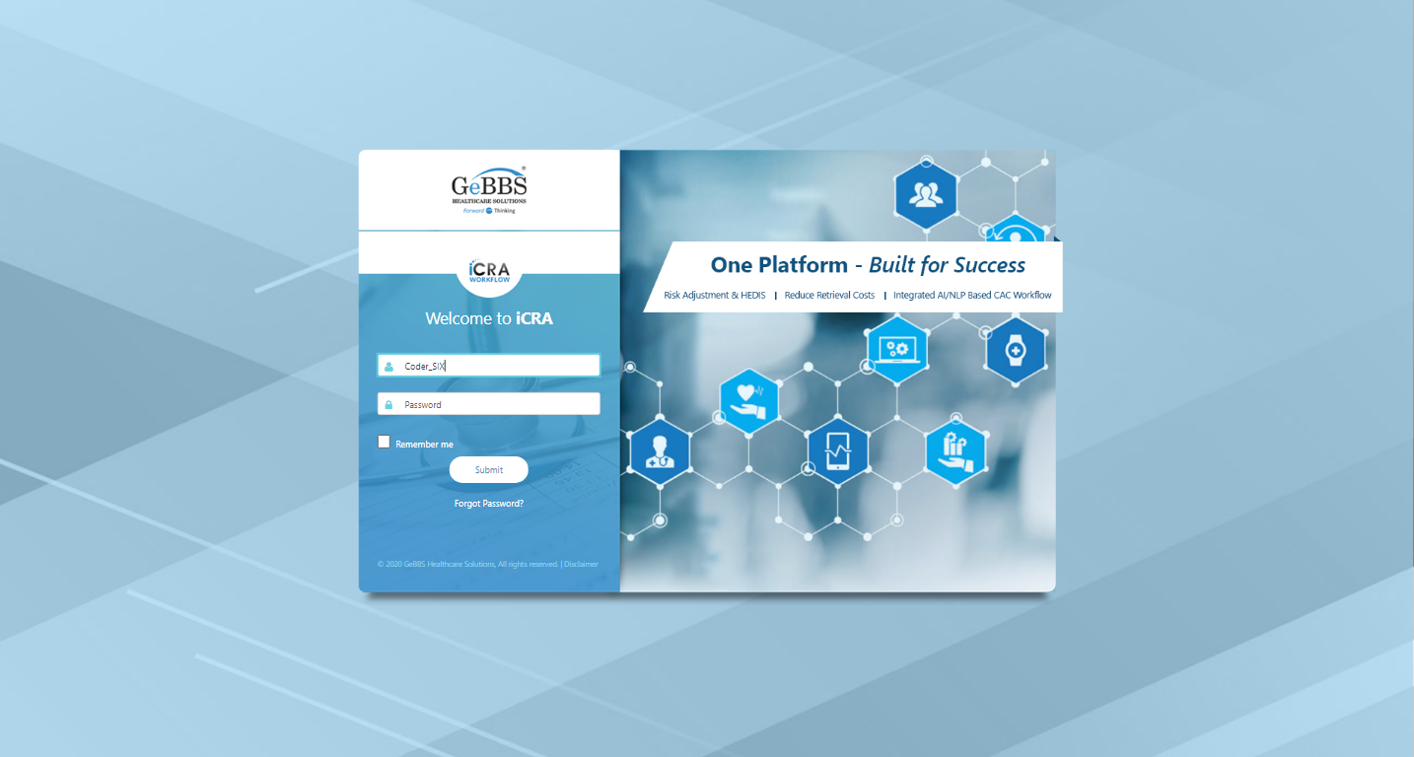  
Password is entered  
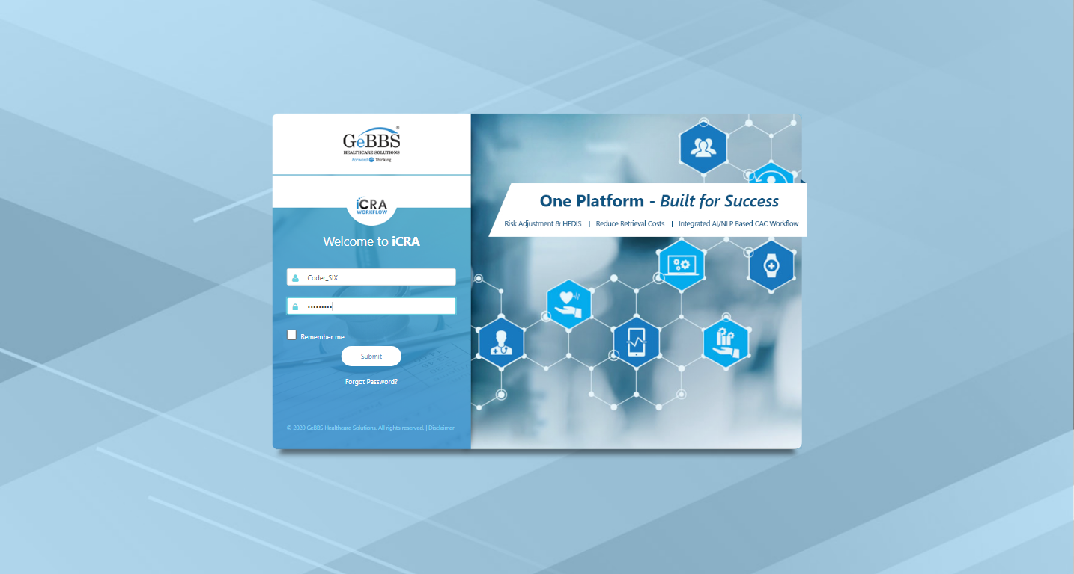  
Submit button is clicked  
Text of the element : Successfully logged in  
Successfully logged in  
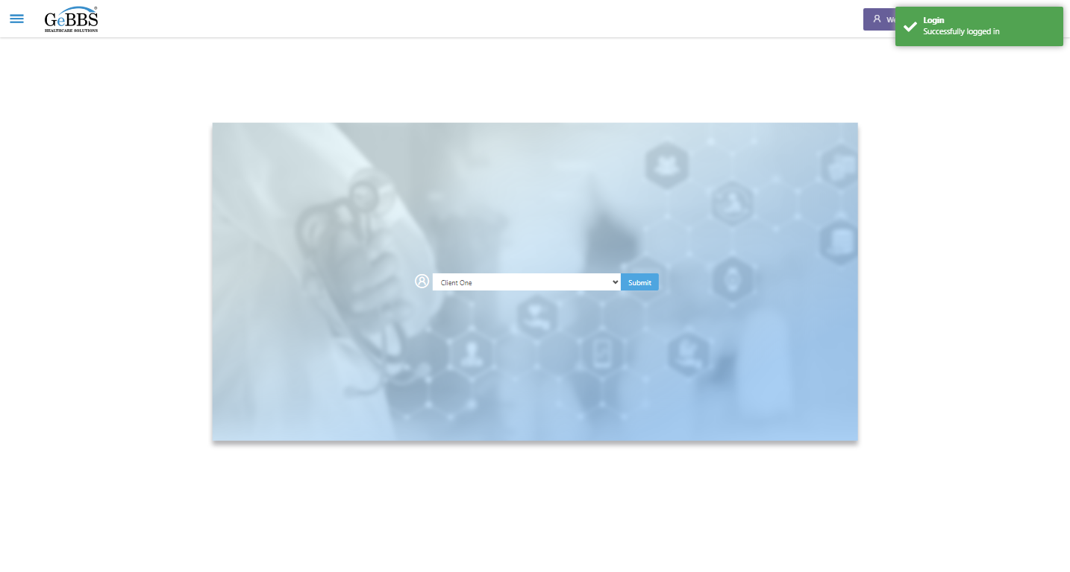  
SelectClient is clicked  
Drop down option at the position 1 is selected  
Submit selected client is clicked  
Desired client found.  
  
Main Page loaded  
  
Scrolled successfully  
Management Reports is clicked  
All submenus  
  
Submenu in 1 is :Charts in Queue Report  
Submenu in 2 is :Coding Review Dashboard  
Submenu in 3 is :HCC Change Report  
Submenu in 4 is :Invoice Report  
Submenu in 5 is :Retrieval Progress Dashboard  
Submenu in 6 is :Review Quality Report  
Scrolled successfully  
Coding Review Dashboard is clicked  
Coding Review Dashboard selected  
  
Frame found and switched to   
Frame found and switched to   
CodingCompletionStatus is displayed  
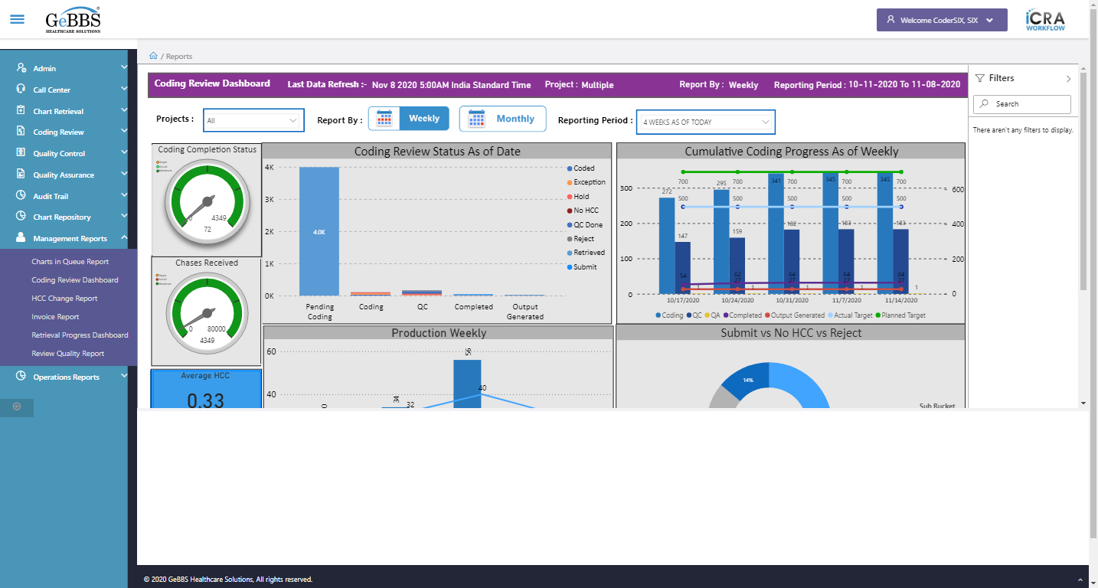  
Chases_Received icon is displayed  
  
AverageHCC image is displayed  
  
AveragePageCount image is displayed  
  
AverageDOS image is displayed  
  
CoderReviewStatus graph is displayed  
  
CumulativeCoding graph is displayed  
  
ProductionWeekly graph is displayed  
  
Submit_NoHCC_Reject graph is displayed  
  
ProjectDropdown is displayed  
  
ReportingPeriod is displayed  
  
ShowFilterPane is displayed  
  
Filters text is displayed  
  
Filters icon is displayed  
  
MonthlyDashboard is displayed  
  
AverageDOSMonthly is displayed  
  
MonthlyPageCount is displayed  
  
CumulativeMonthlyDrill is displayed  
  
CumulativeMonthlyOut is displayed  
  
Search_Filter is displayed  
  
Attribute for title is : Multiple  
Project name is displayed at header is correct  
  
Project name field is correct  
  
Reporting period value i.e 4 WEEKS AS OF TODAY is selected by default  
  
ReportingBy_Weekly is displayed  
  
ReportingBy_Monthly is displayed  
  
ReportbyTitle2 i.e weekly is displayed  
  
MonthlyDashboard is clicked  
CodingCompletionStatus is displayed  
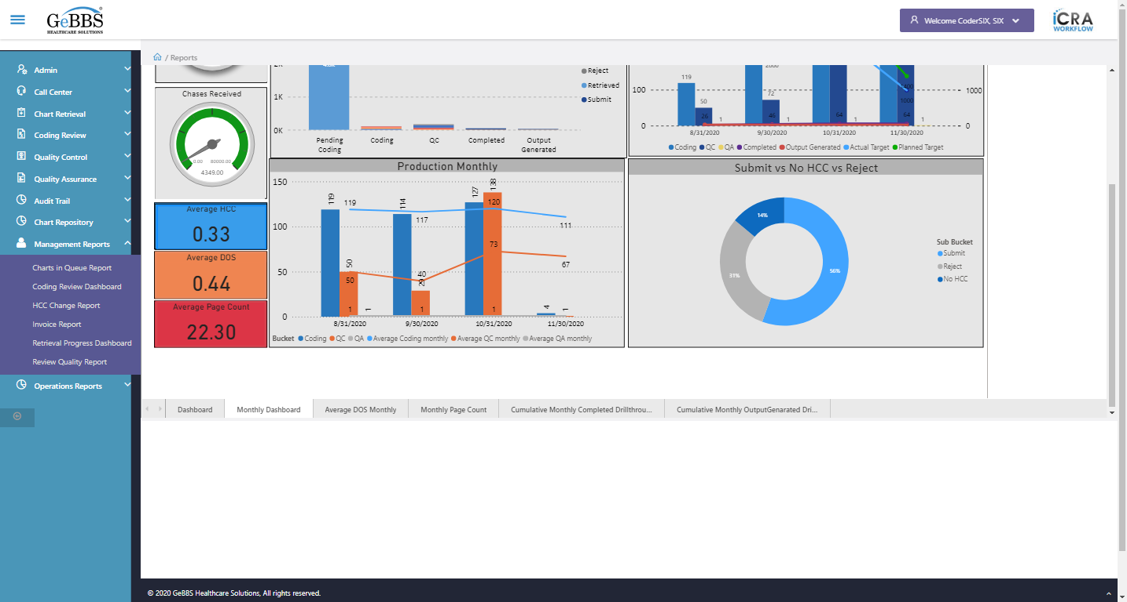  
Chases_Received icon is displayed  
  
AverageHCC image is displayed  
  
AveragePageCount image is displayed  
  
AverageDOS image is displayed  
  
CoderReviewStatus graph is displayed  
  
CumulativeCoding graph is displayed  
  
ProductionMonthly graph is displayed  
  
Submit_NoHCC_Reject graph is displayed  
  
ProjectDropdown is displayed  
  
ReportingPeriod is displayed  
  
ShowFilterPane is displayed  
  
Filters text is displayed  
  
Filters icon is displayed  
  
MonthlyDashboard is displayed  
  
AverageDOSMonthly is displayed  
  
MonthlyPageCount is displayed  
  
CumulativeMonthlyDrill is displayed  
  
CumulativeMonthlyOut is displayed  
  
Search_Filter is displayed  
  
ReportbyTitle1 i.e Monthly is displayed  
  
ReportingPeriod is displayed  
  
Reporting period value i.e 3 MONTHS AS OF TODAY is selected by default  
  
Average DOS Monthly is clicked  
Backarrow is displayed  
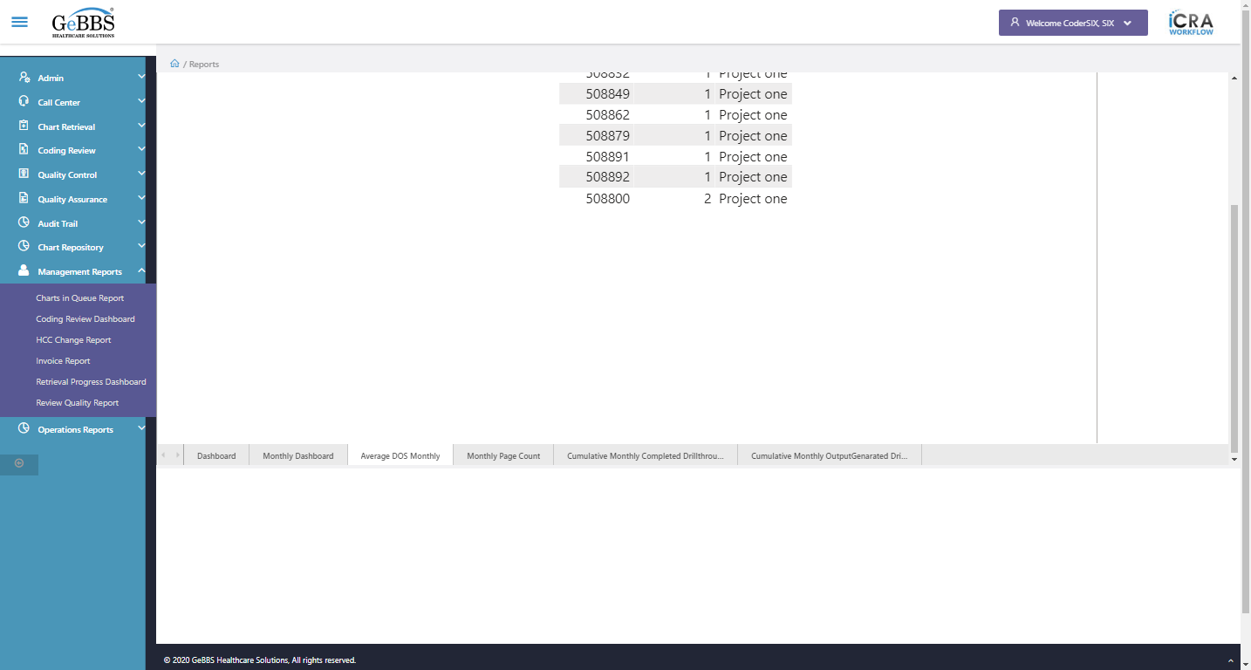  
ShowFilterPane is displayed  
  
filtersection is displayed  
  
Records is displayed  
  
Coloumn_1 is displayed i.e ChaseID  
  
SortIcon_1 is displayed  
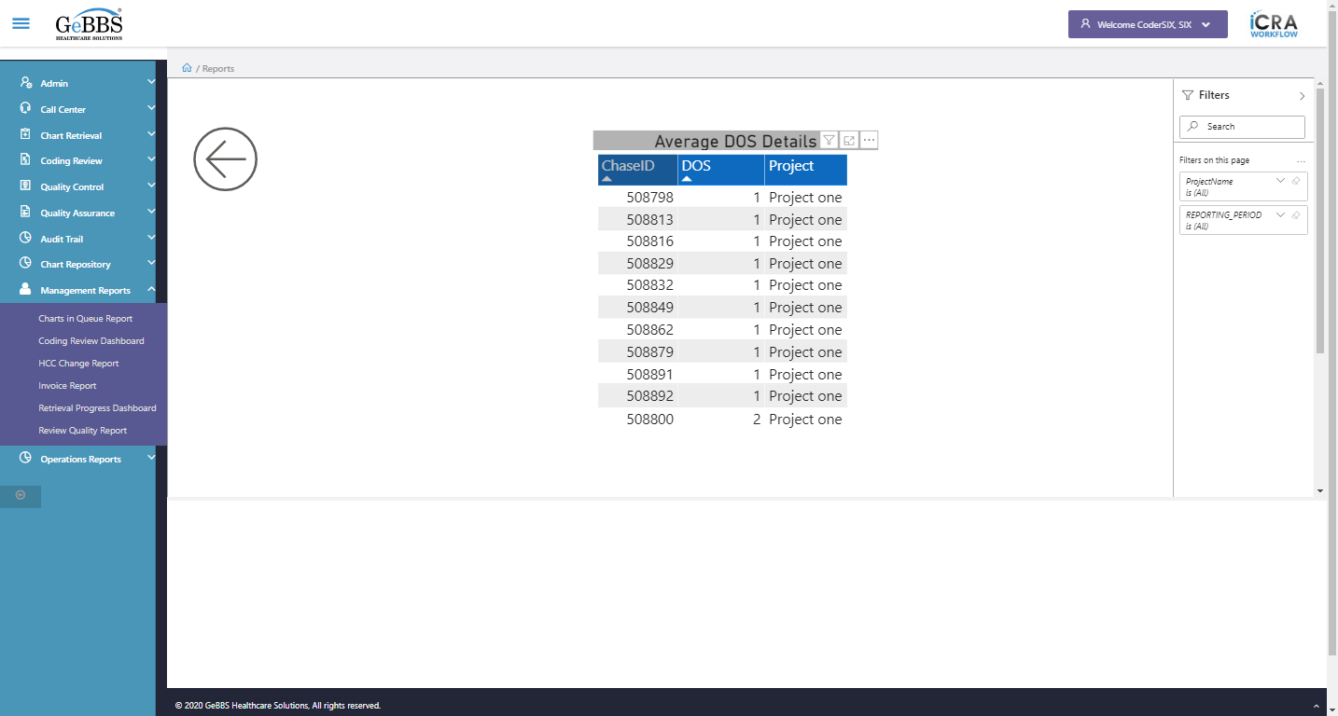  
Coloumn_2 is displayed i.e DOS
  
  
SortIcon_2 is displayed  
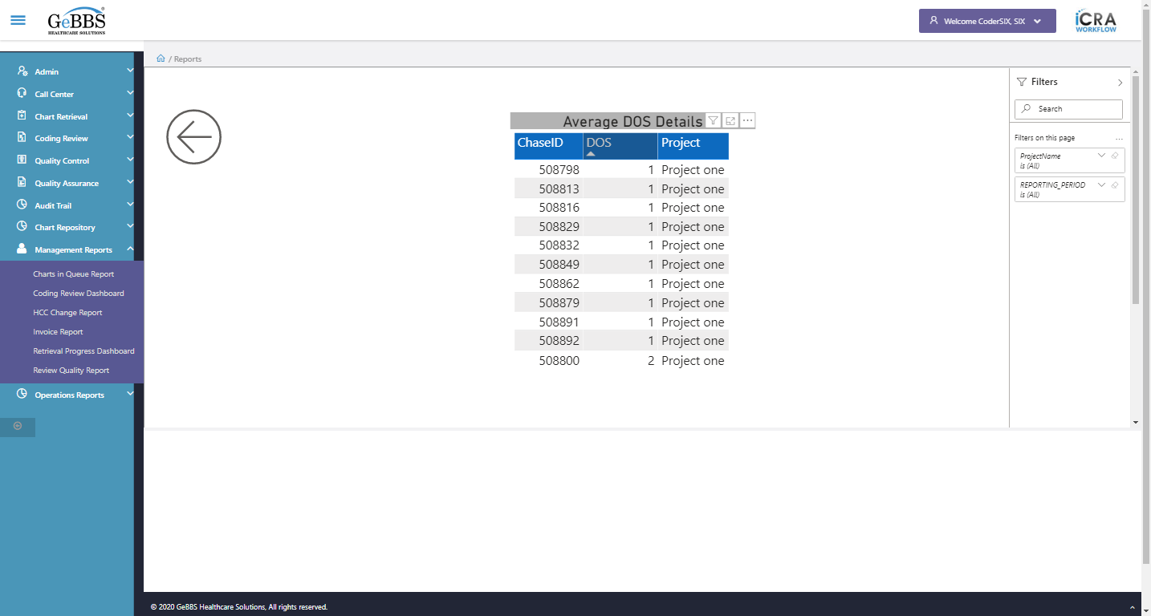  
Coloumn_3 is displayed i.e Project  
  
SortIcon_3 is displayed  
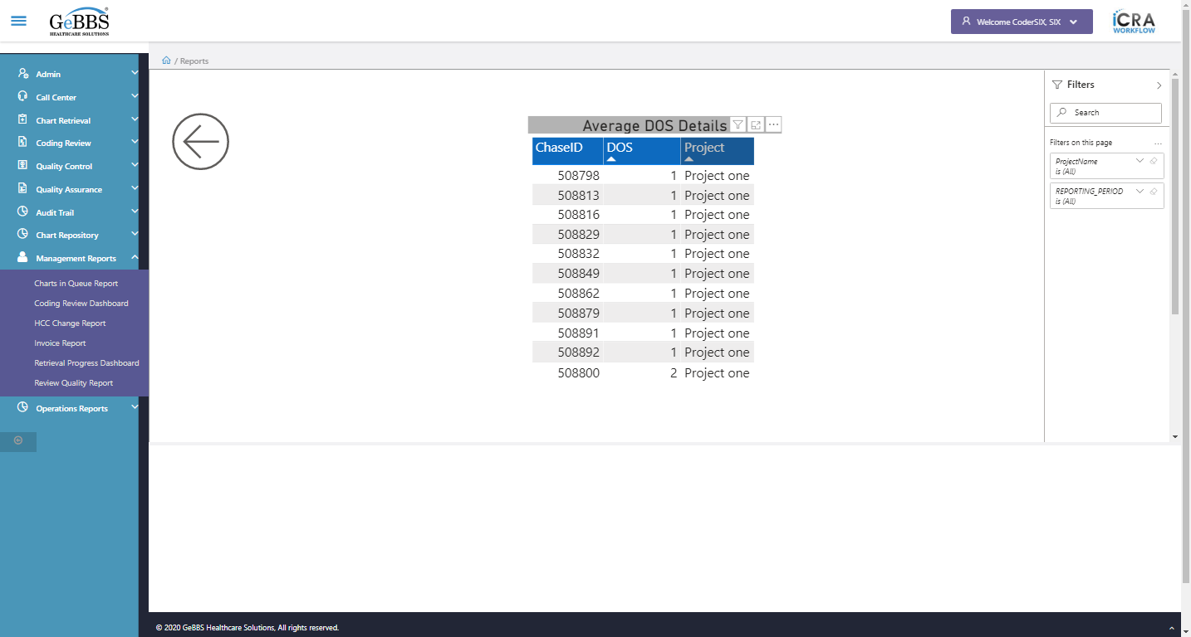  
Heading is clicked  
FilterIcon is displayed  
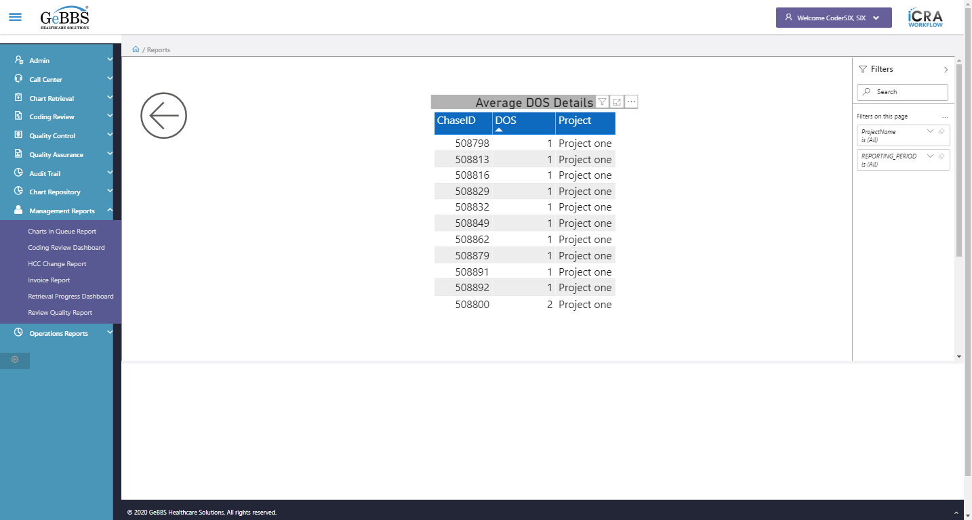  
Attribute for style is : position: absolute; overflow: hidden; width: 352px; height: 311px;  
FocusMode is displayed  
  
FocusMode is clicked  
Attribute for style is : position: absolute; overflow: hidden; width: 1424px; height: 347px;  
Focus mode is working  
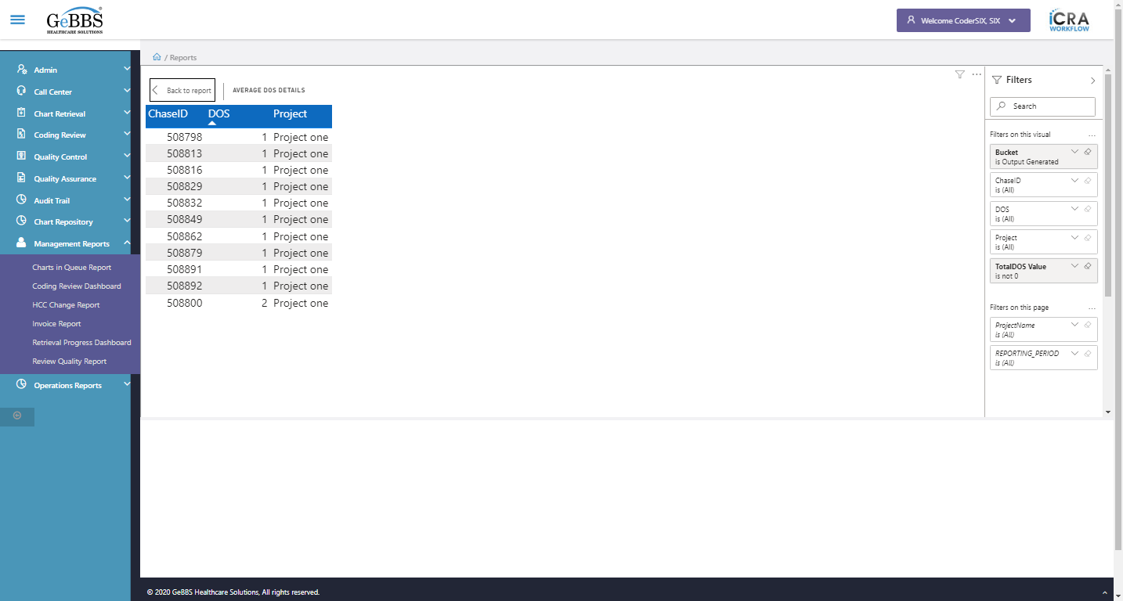  
BackReporticon is clicked  
MoreOptions is displayed  
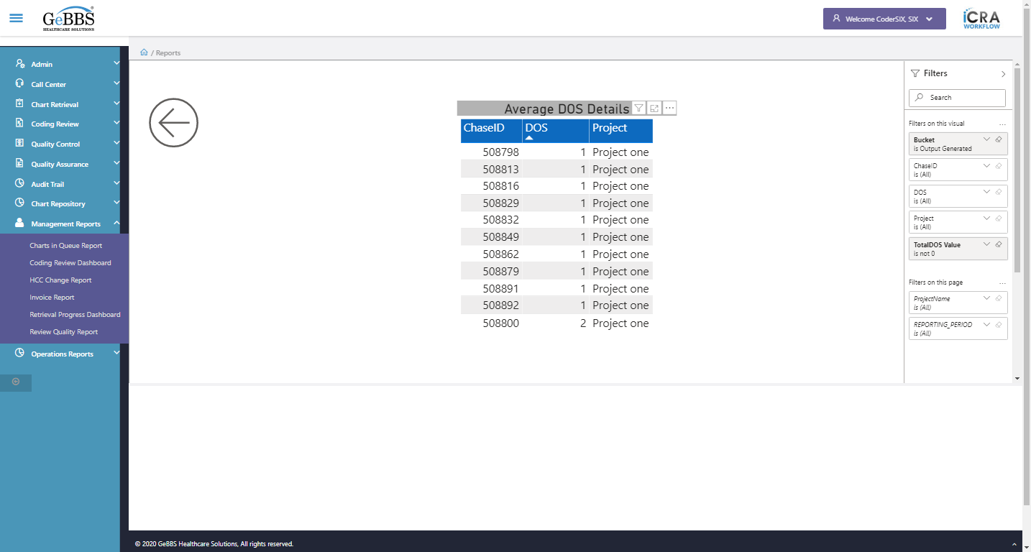  
MoreOptions is clicked  
ExportData_Menu is displayed  
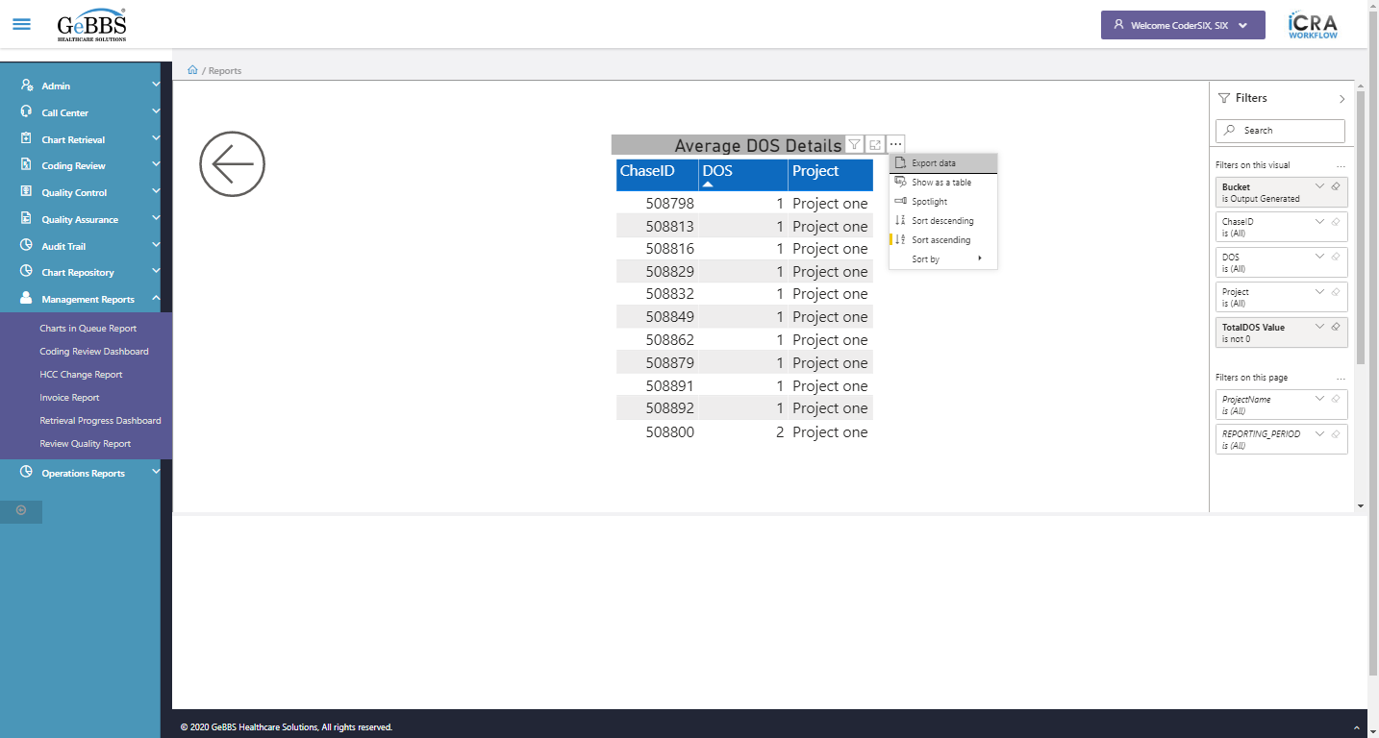  
Showtbl_Menu is displayed  
  
Sortaec_Menu is displayed  
  
Sortdec_Menu is displayed  
  
Sortby_Menu is displayed  
  
Sortaec_Menu is not disable  
  
Sortdec_Menu is not disable  
  
Sortby_Menu is clicked  
ChaseID_Menu is displayed  
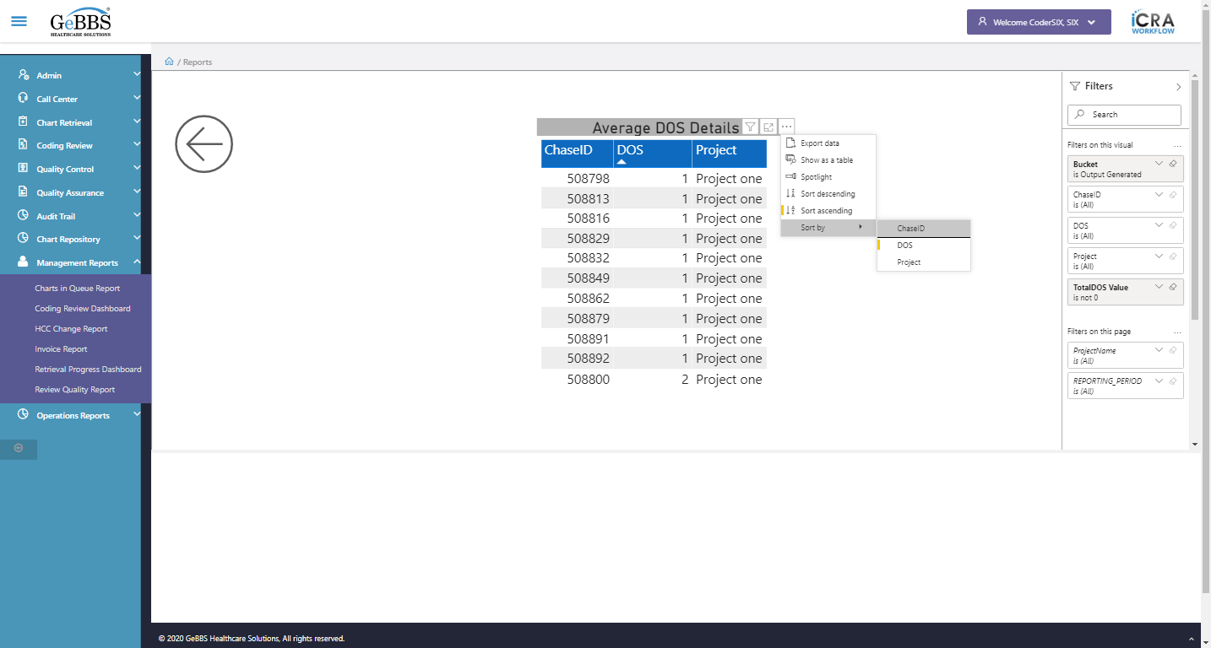  
DOS_Menu is displayed  
  
******** AverageDOSMonthly checked *********  
Monthly Page Count is clicked  
Backarrow is displayed  
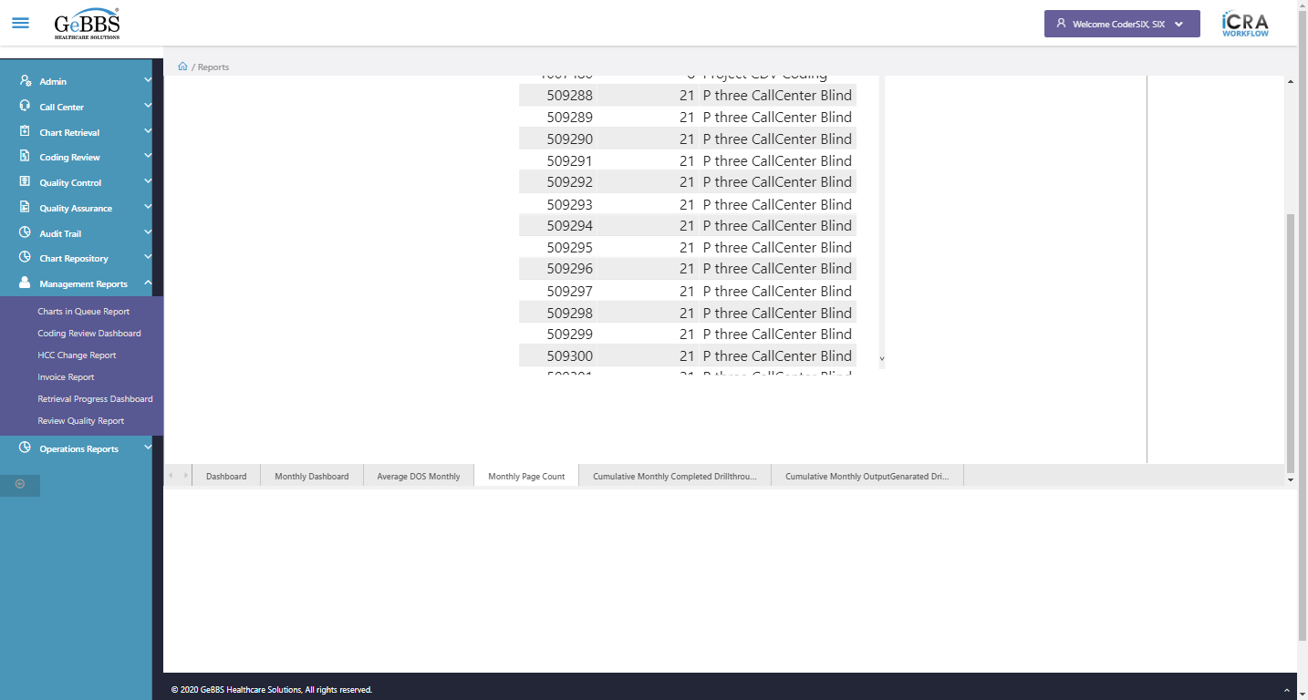  
ShowFilterPane is displayed  
  
Records is displayed  
  
Coloumn_1 is displayed i.e ChaseID  
  
SortIcon_1 is displayed  
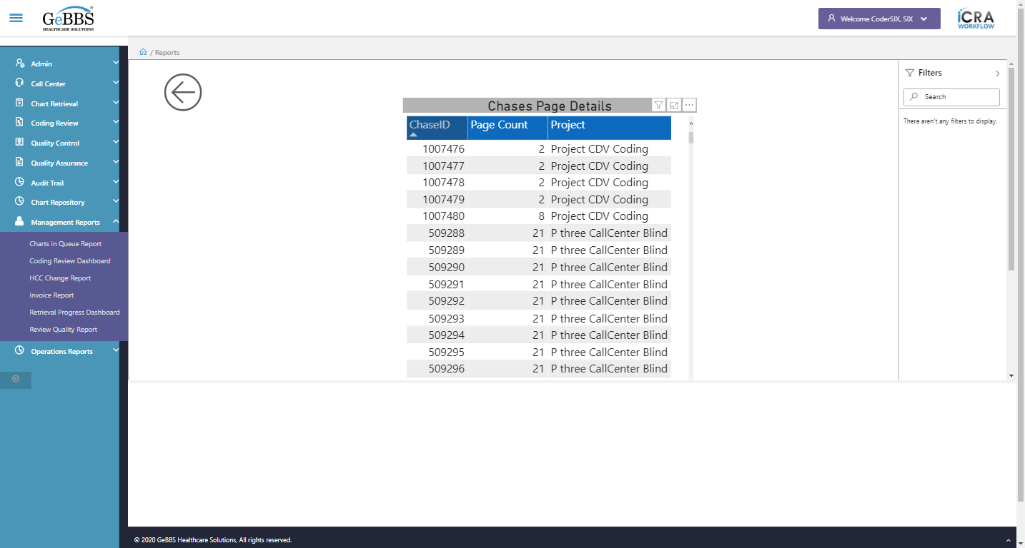  
Coloumn_2 is displayed i.e Page Count  
  
SortIcon_2 is displayed  
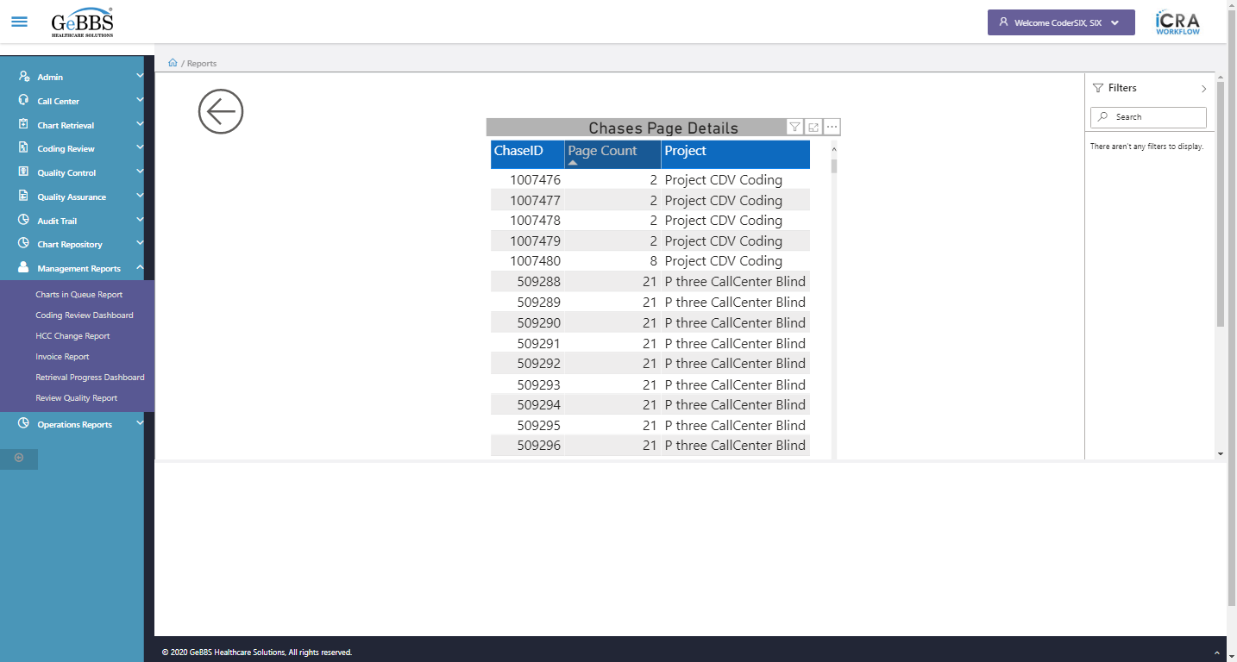  
Coloumn_3 is displayed i.e Project  
  
SortIcon_3 is displayed  
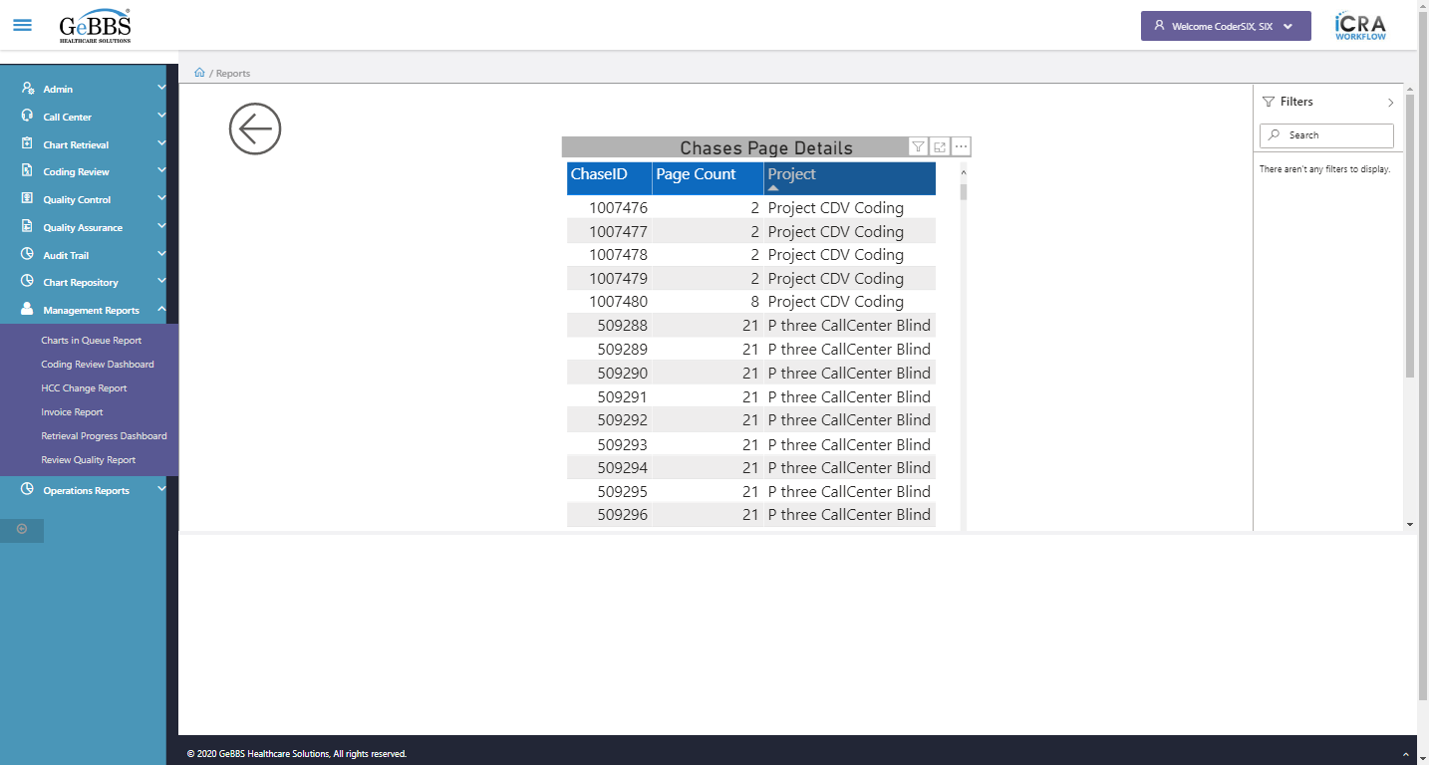  
Heading is clicked  
FilterIcon is displayed  
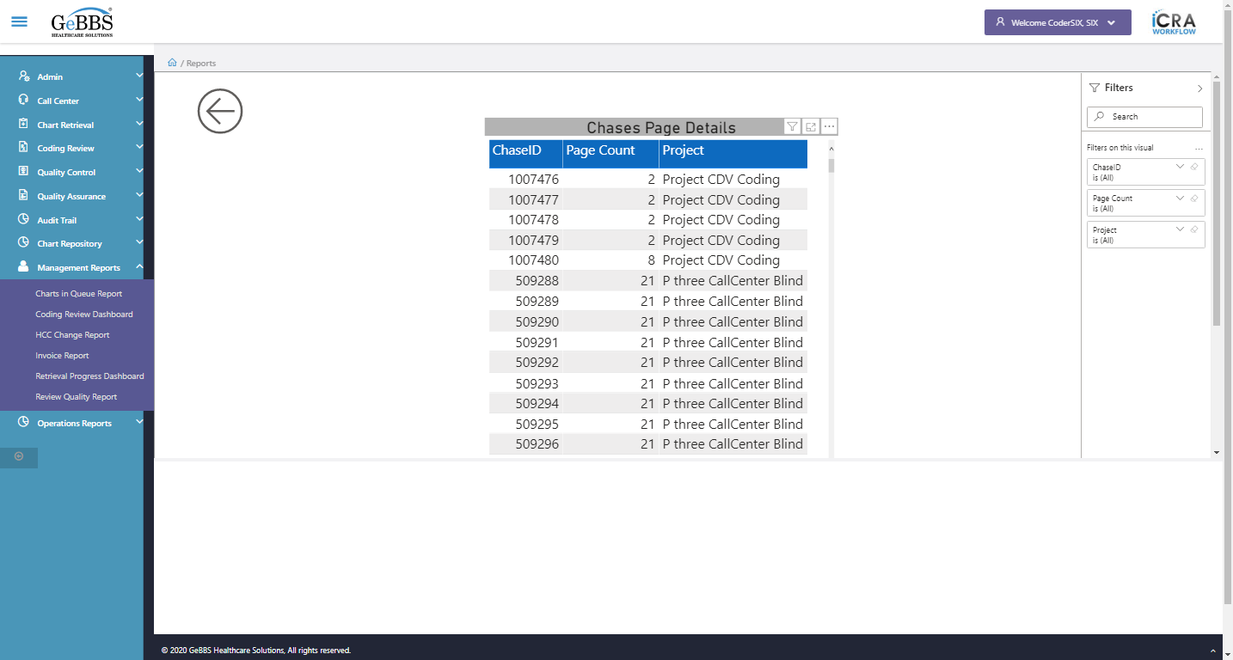  
Attribute for style is : position: absolute; overflow: hidden; width: 469px; height: 14125px;  
FocusMode is displayed  
  
FocusMode is clicked  
Attribute for style is : position: absolute; overflow: hidden; width: 1415px; height: 14125px;  
Focus mode is working  
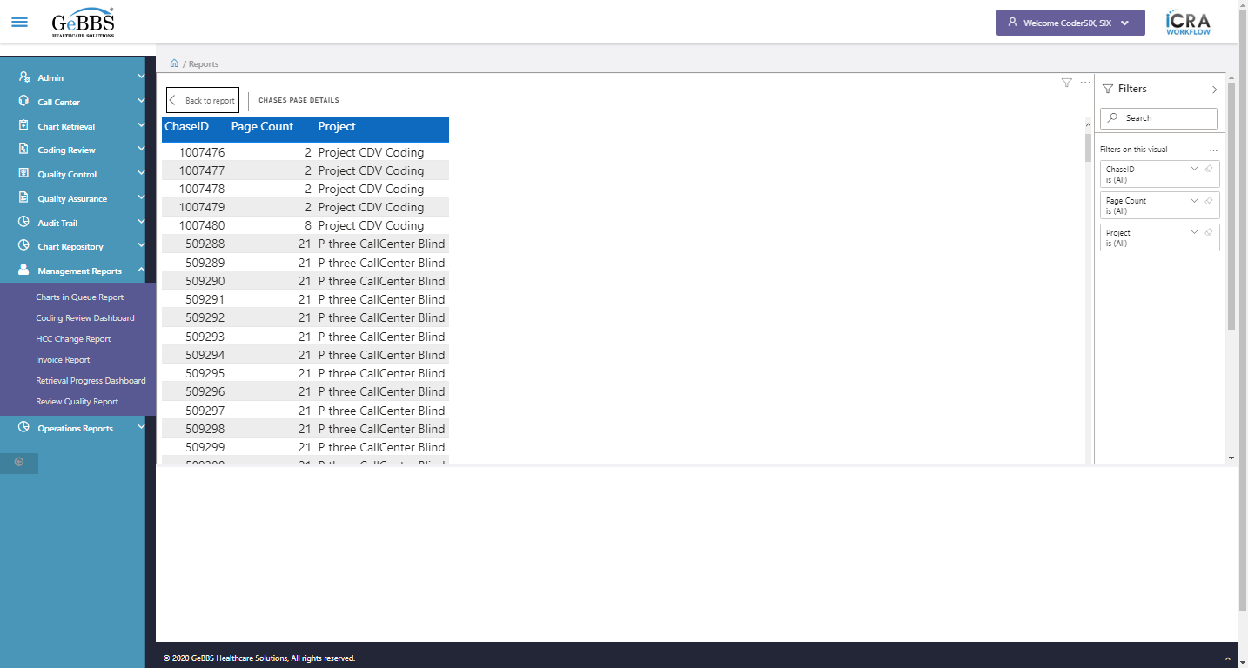  
BackReporticon is clicked  
MoreOptions is displayed  
  
MoreOptions is clicked  
ExportData_Menu is displayed  
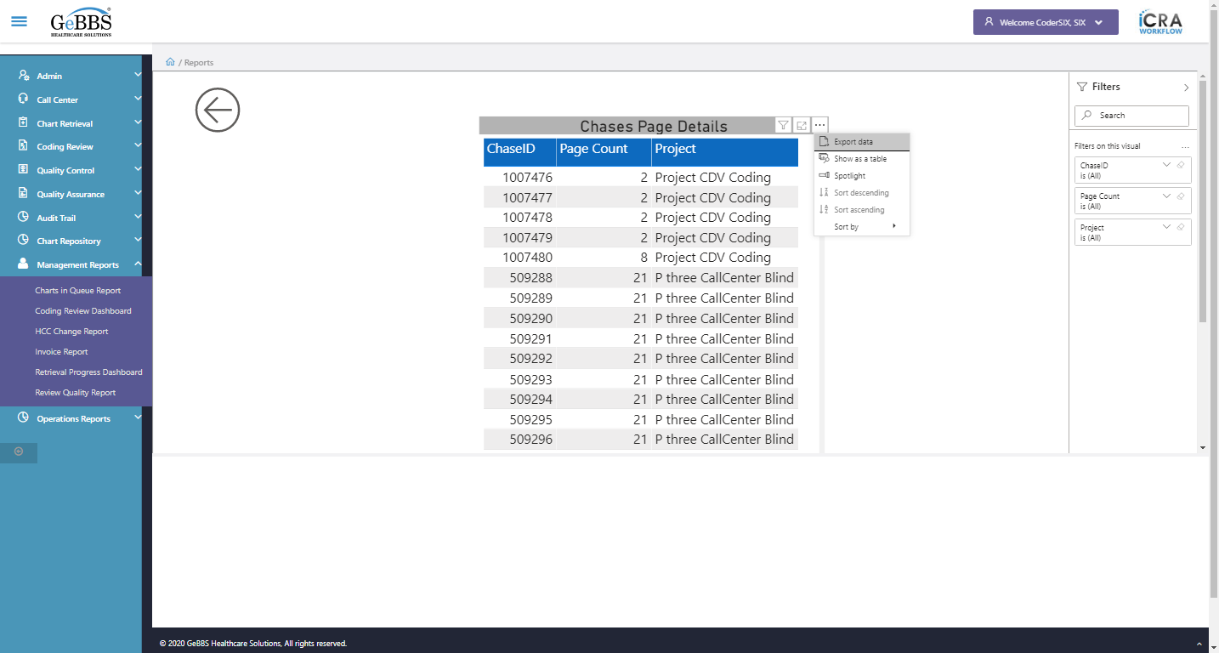  
Showtbl_Menu is displayed  
  
Sortaec_Menu is displayed  
  
Sortdec_Menu is displayed  
  
Sortby_Menu is displayed  
  
Sortaec_Menu is disable  
  
Sortdec_Menu is disable  
  
Sortby_Menu is clicked  
ChaseID_Menu is displayed  
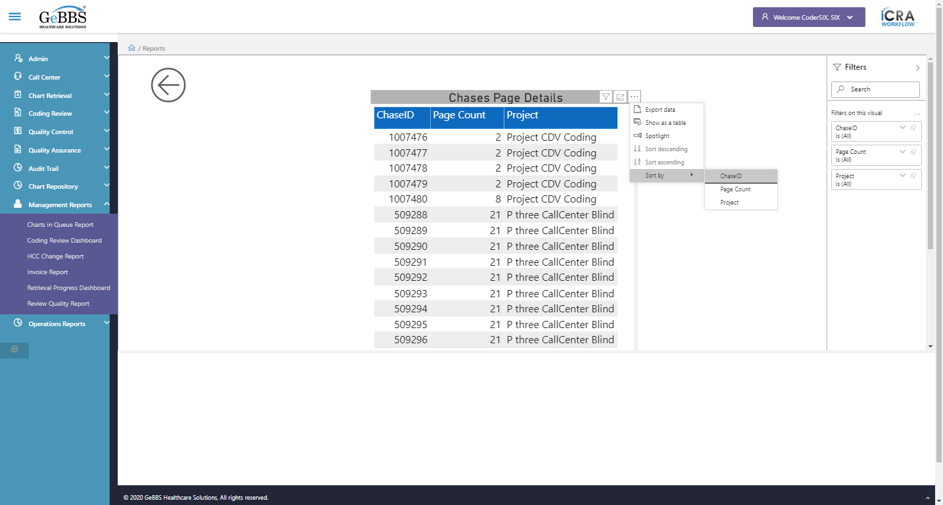  
PageCount_Menu is displayed  
  
******* MonthlyPageCount checked *******  
NextPageIcon is clicked  
Cumulative Monthly Completed Drillthrough is clicked  
Backarrow is displayed  
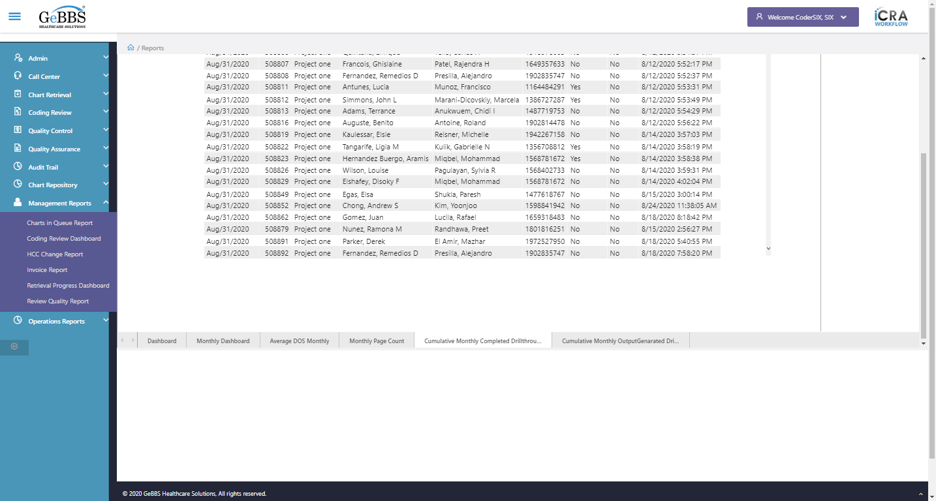  
ShowFilterPane is displayed  
  
filtersection is displayed  
  
Records is displayed  
  
Coloumn_1 is displayed i.e Reporting Date  
  
SortIcon_1 is displayed  
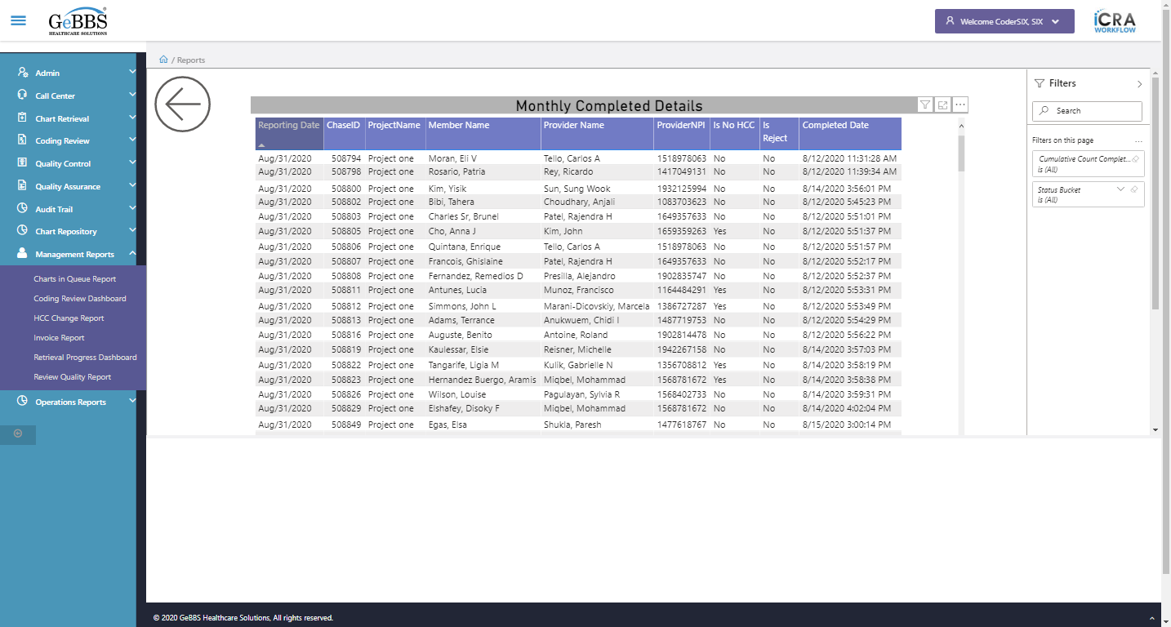  
Coloumn_2 is displayed i.e ChaseID  
  
SortIcon_2 is displayed  
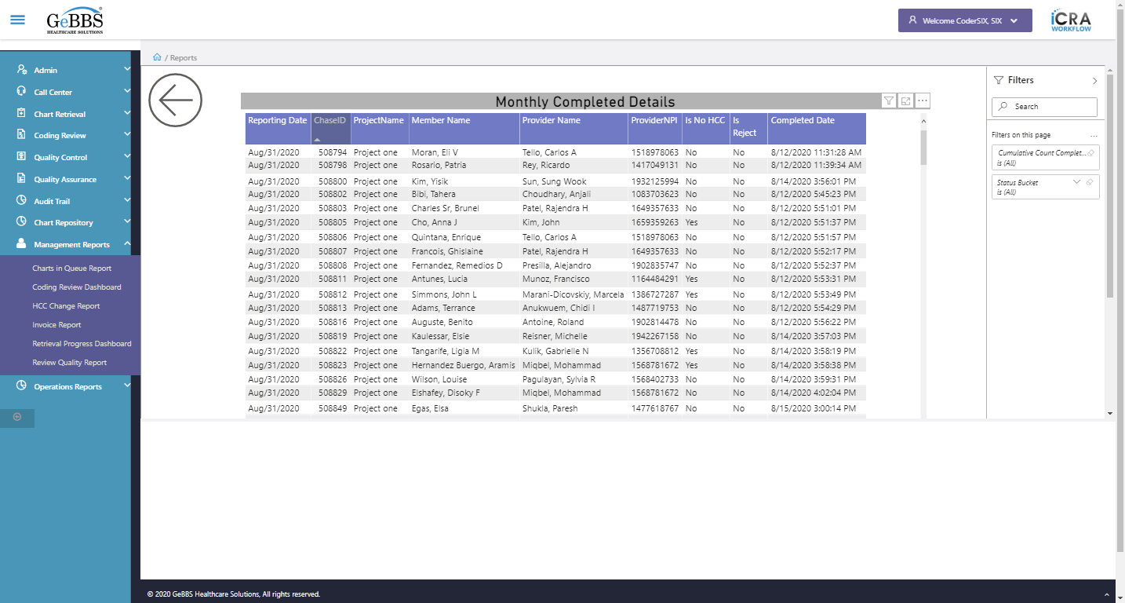  
Coloumn_3 is displayed i.e ProjectName  
  
SortIcon_3 is displayed  
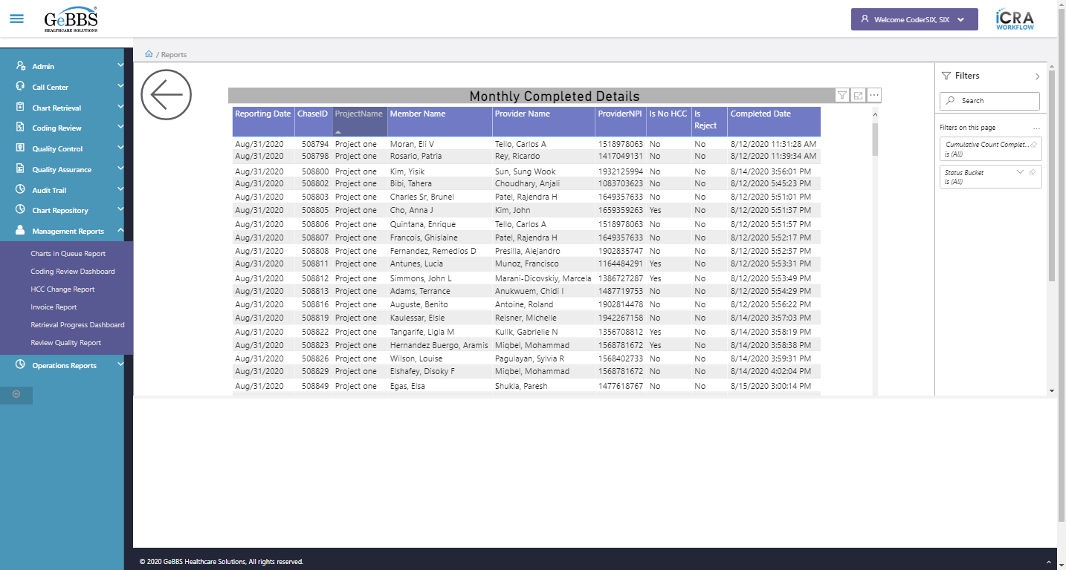  
Coloumn_4 is displayed i.e Member Name  
  
SortIcon_4 is displayed  
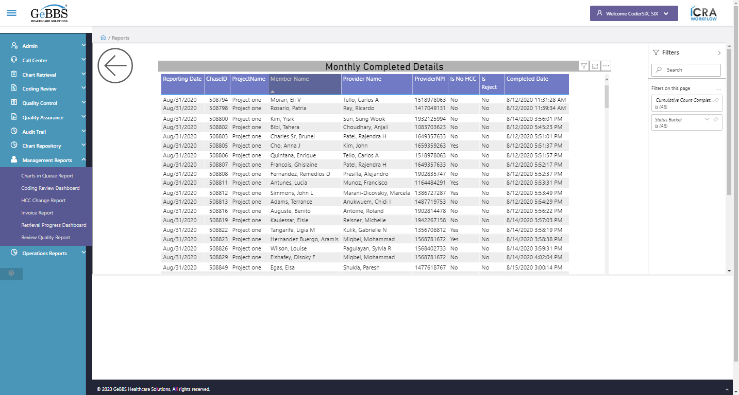  
Coloumn_5 is displayed i.e Provider Name  
  
SortIcon_5 is displayed  
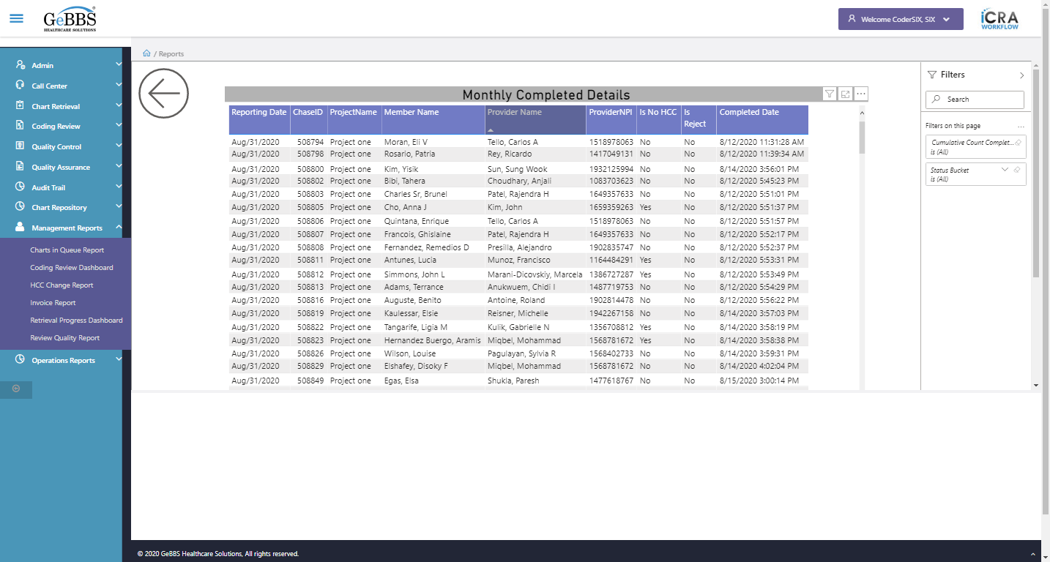  
Coloumn_6 is displayed i.e ProviderNPI  
  
SortIcon_6 is displayed  
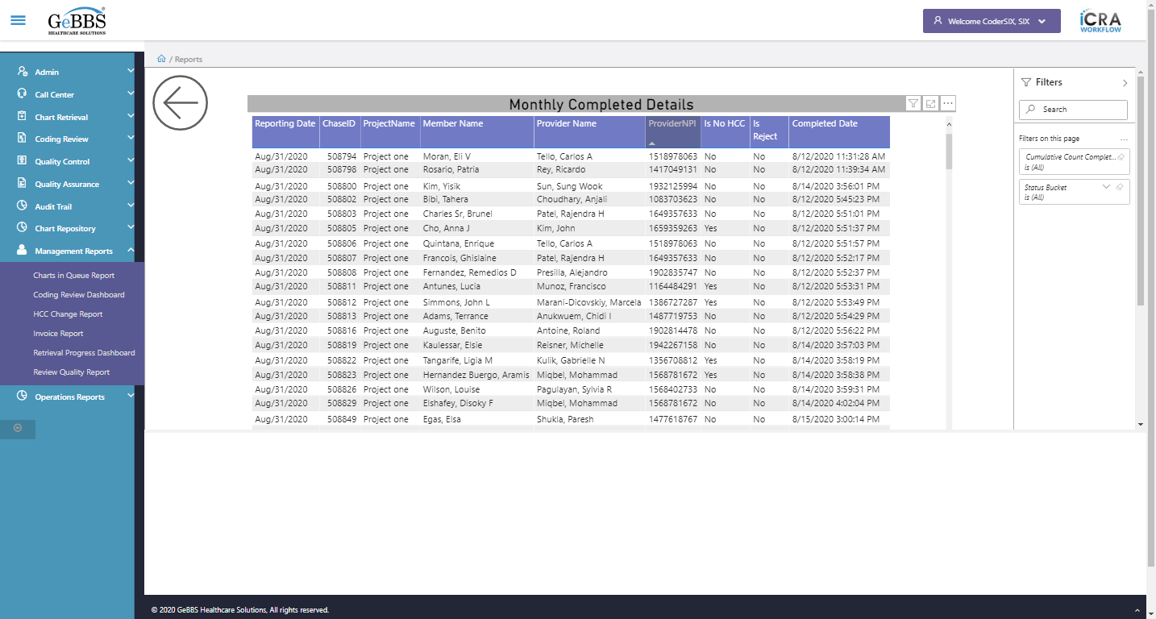  
Coloumn_7 is displayed i.e Is No HCC  
  
SortIcon_7 is displayed  
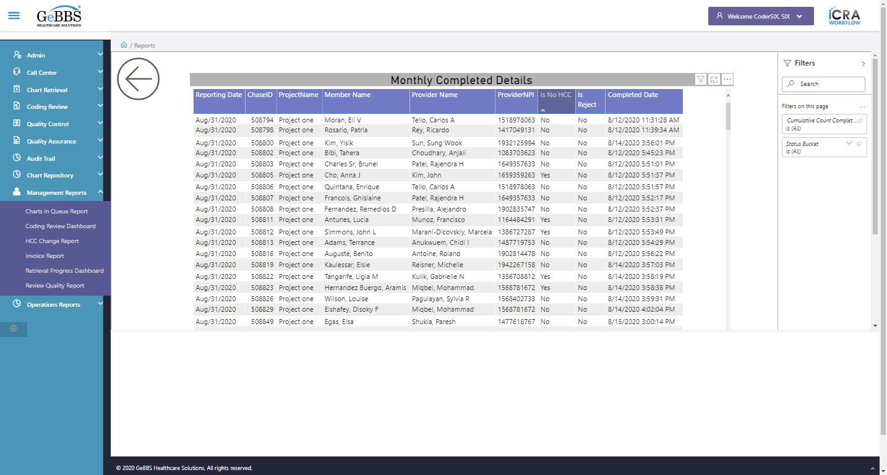  
Coloumn_8 is displayed i.e Is Reject  
  
SortIcon_8 is displayed  
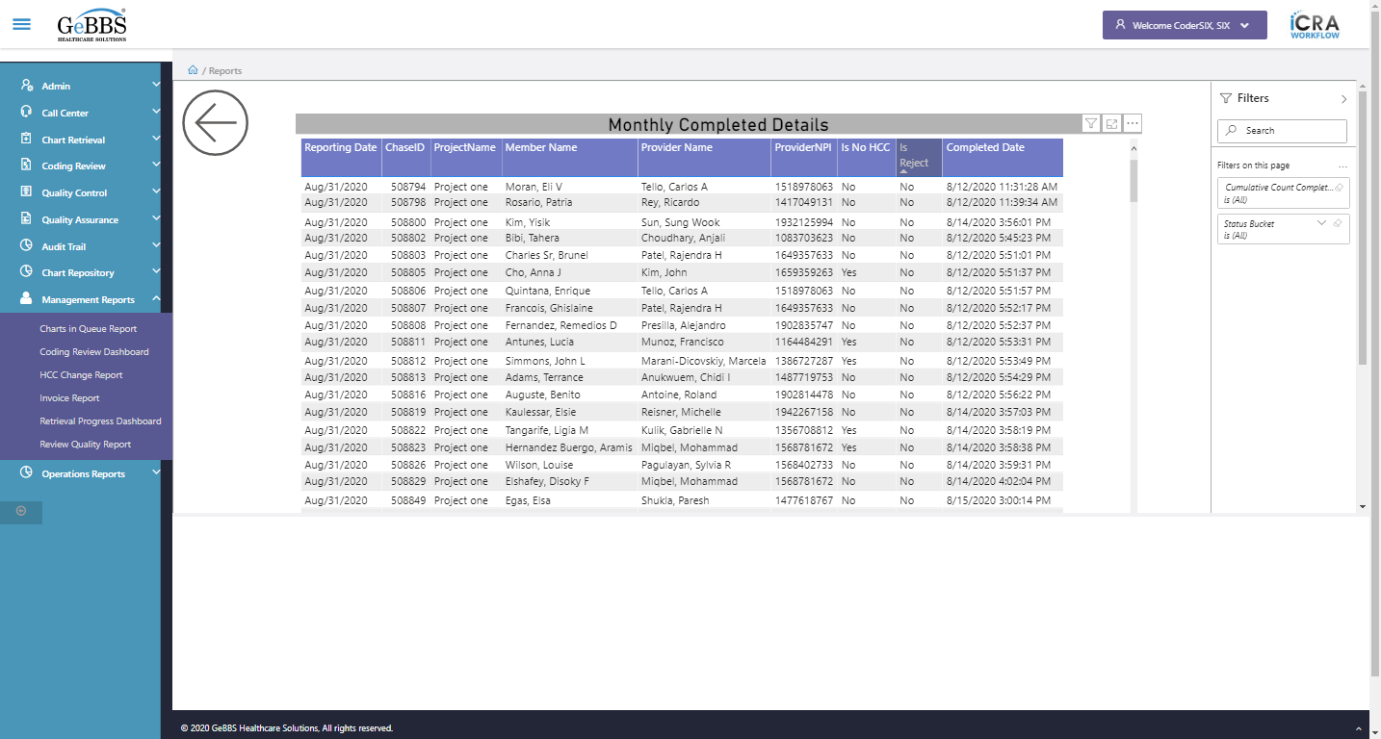  
Coloumn_9 is displayed i.e Completed Date  
  
SortIcon_9 is displayed  
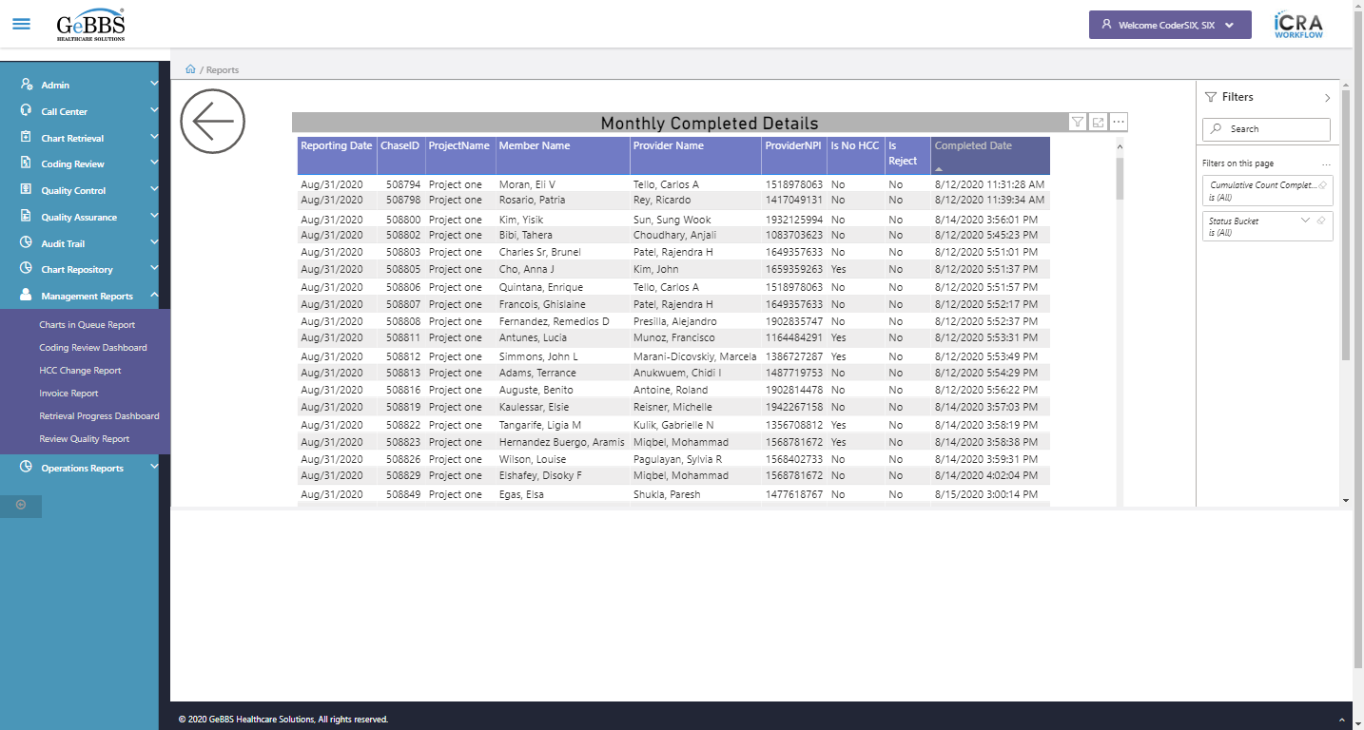  
Heading is clicked  
FilterIcon is displayed  
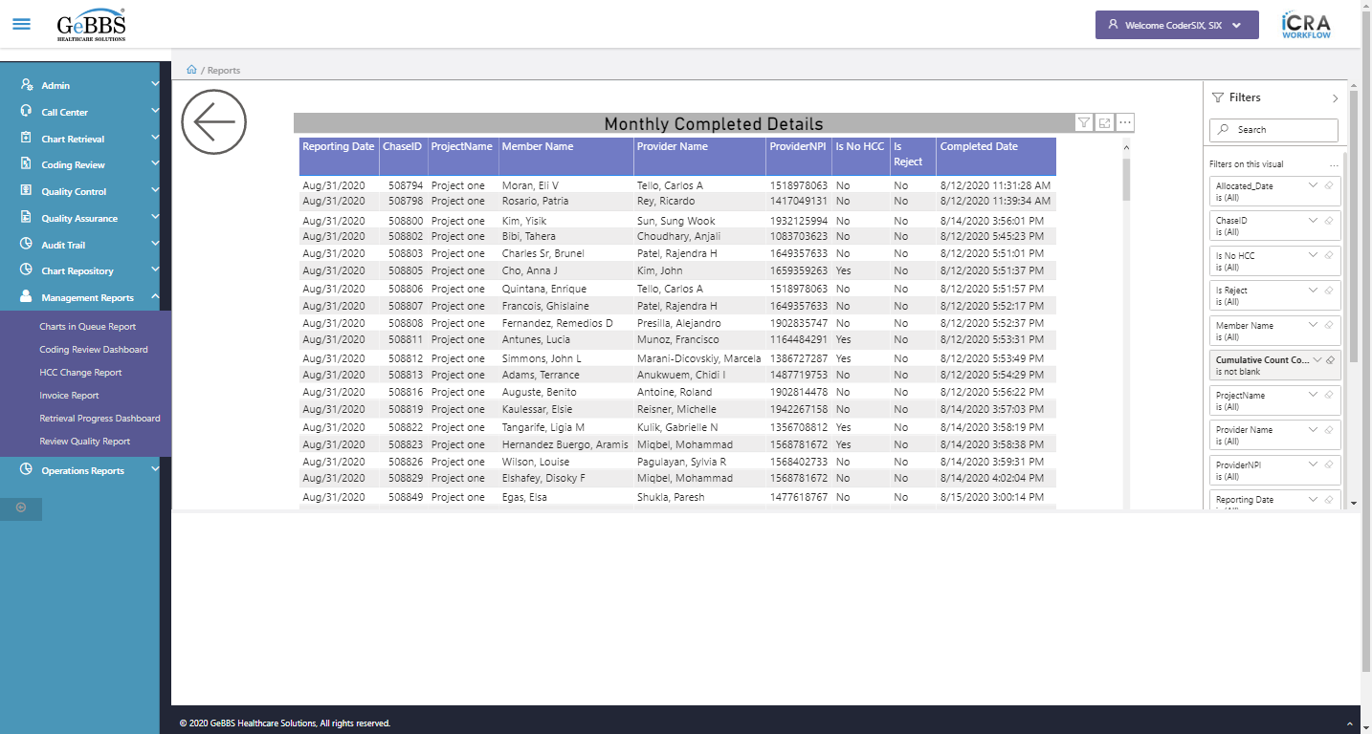  
Attribute for style is : position: absolute; overflow: hidden; width: 1024px; height: 5054px;  
FocusMode is displayed  
  
FocusMode is clicked  
Attribute for style is : position: absolute; overflow: hidden; width: 1415px; height: 5054px;  
Focus mode is working  
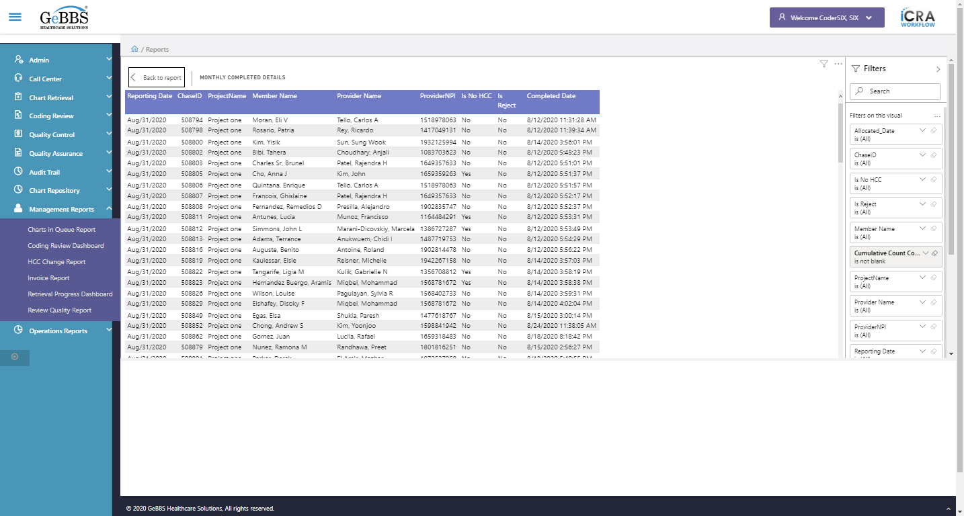  
BackReporticon is clicked  
MoreOptions is displayed  
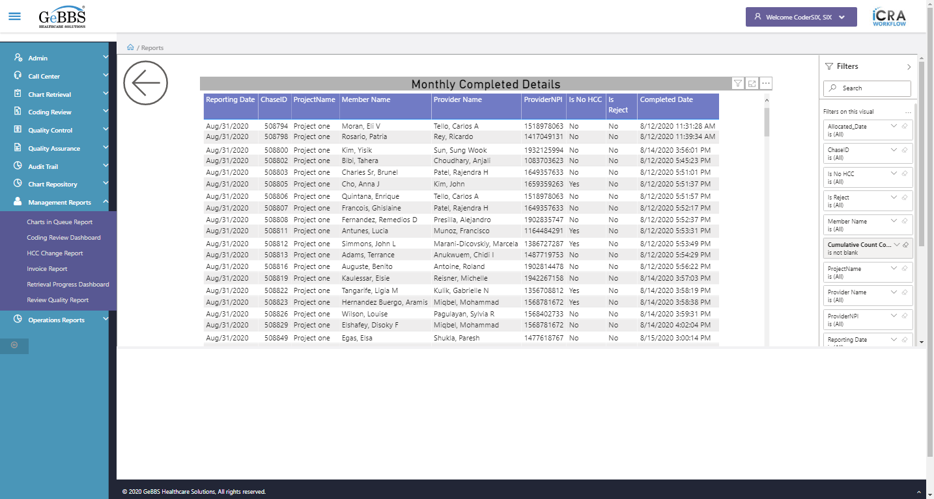  
MoreOptions is clicked  
ExportData_Menu is displayed  
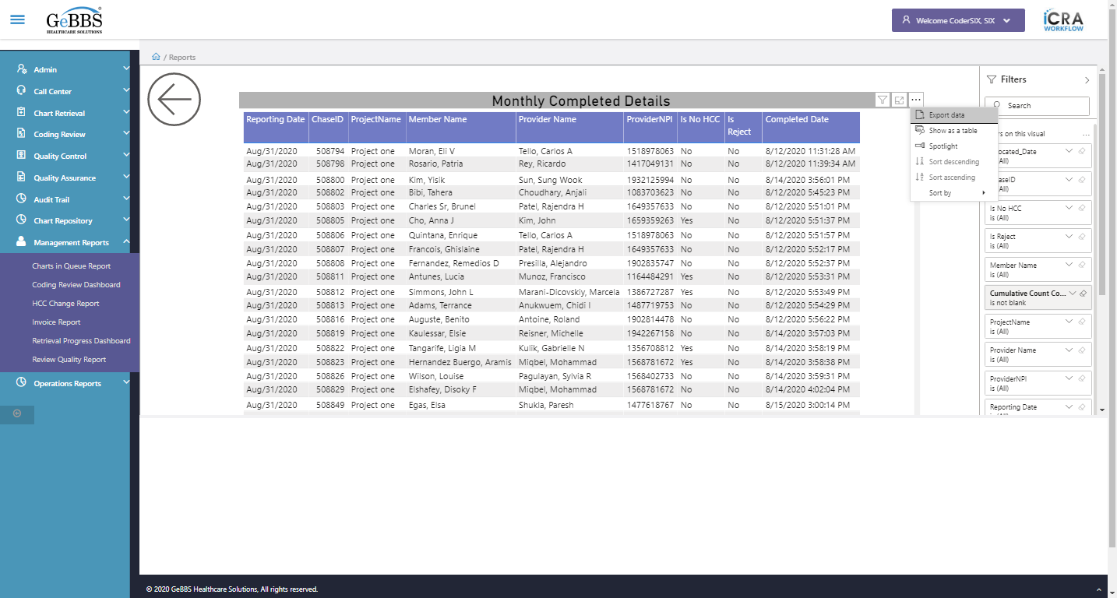  
Showtbl_Menu is displayed  
  
Sortaec_Menu is displayed  
  
Sortdec_Menu is displayed  
  
Sortby_Menu is displayed  
  
Sortaec_Menu is disable  
  
Sortdec_Menu is disable  
  
Sortby_Menu is clicked  
ReportingDate_Menu is displayed  
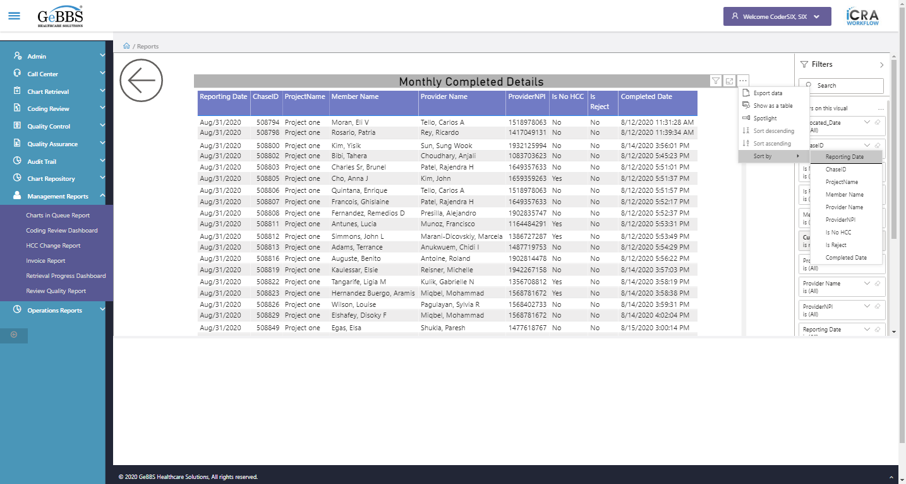  
ChaseID_Menu is displayed  
  
Project_Menu is displayed  
  
MemberName_Menu is displayed  
  
ProviderNPI_Menu is displayed  
  
ProviderName_Menu is not displayed  
  
IsNoHCC_Menu is displayed  
  
IsReject_Menu is displayed  
  
CompletedDate_Menu is displayed  
  
******** CumulativeMonthlyDrill checked ********  
Cumulative Monthly OutputGenarated Drillthrough is clicked  
Backarrow is displayed  
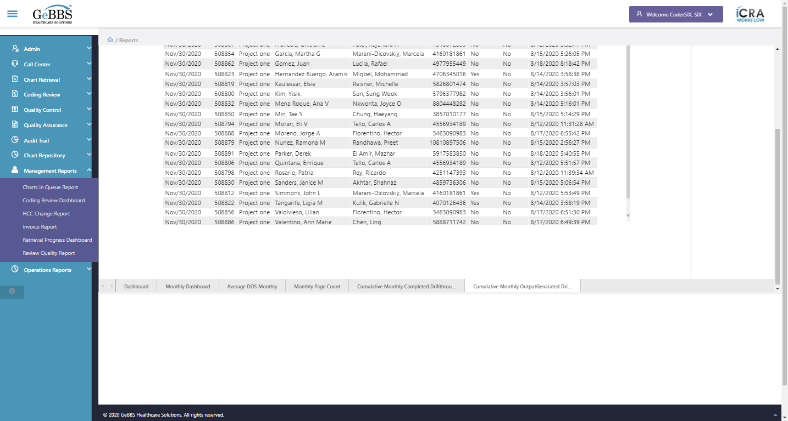  
ShowFilterPane is displayed  
  
filtersection is displayed  
  
Records is displayed  
  
Coloumn_1 is displayed i.e Reporting Date  
  
SortIcon_1 is displayed  
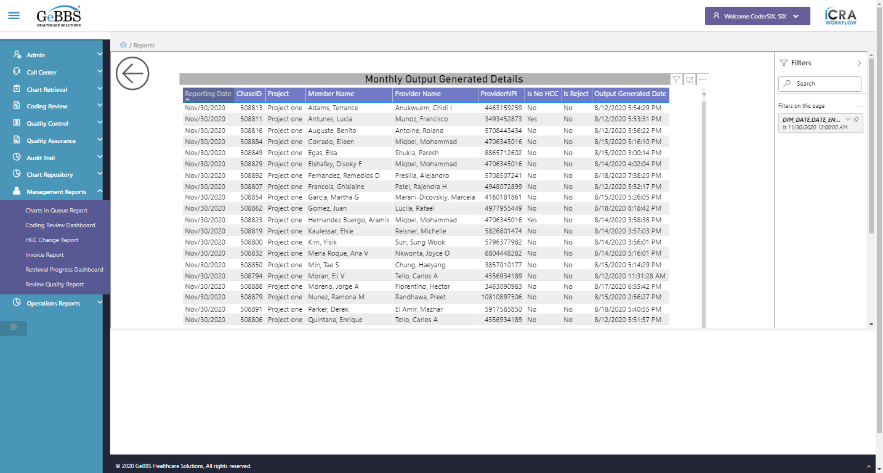  
Coloumn_2 is displayed i.e ChaseID  
  
SortIcon_2 is displayed  
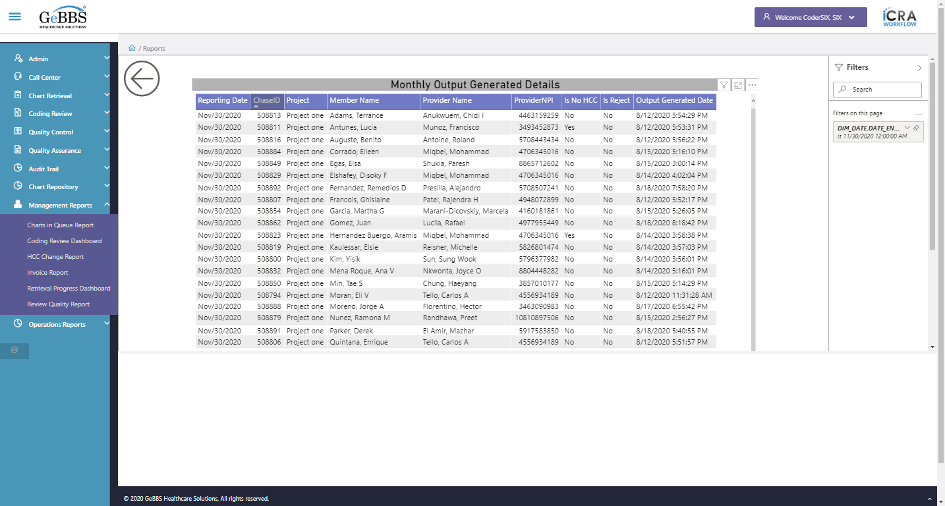  
Coloumn_3 is displayed i.e Project  
  
SortIcon_3 is displayed  
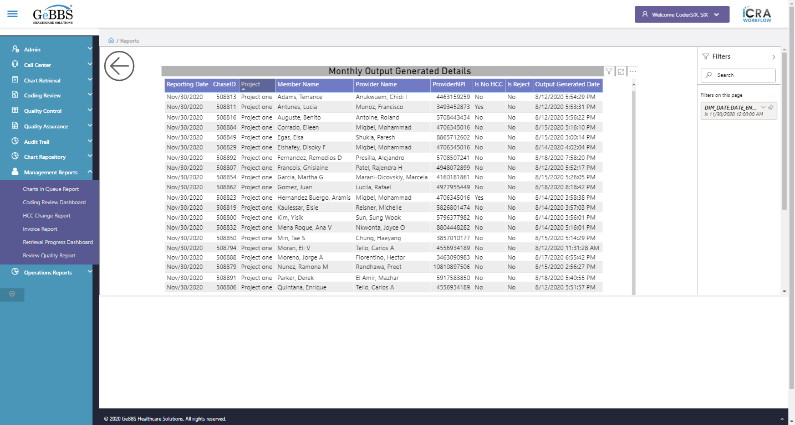  
Coloumn_4 is displayed i.e Member Name  
  
SortIcon_4 is displayed  
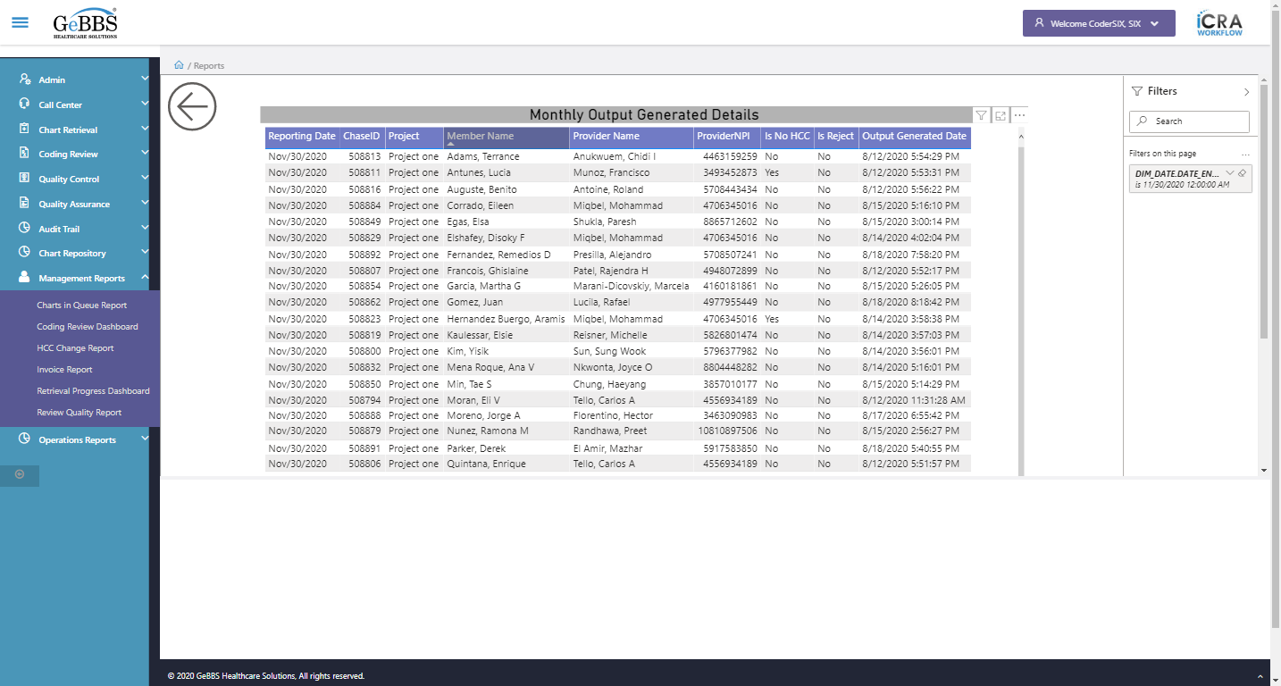  
Coloumn_5 is displayed i.e Provider Name  
  
SortIcon_5 is displayed  
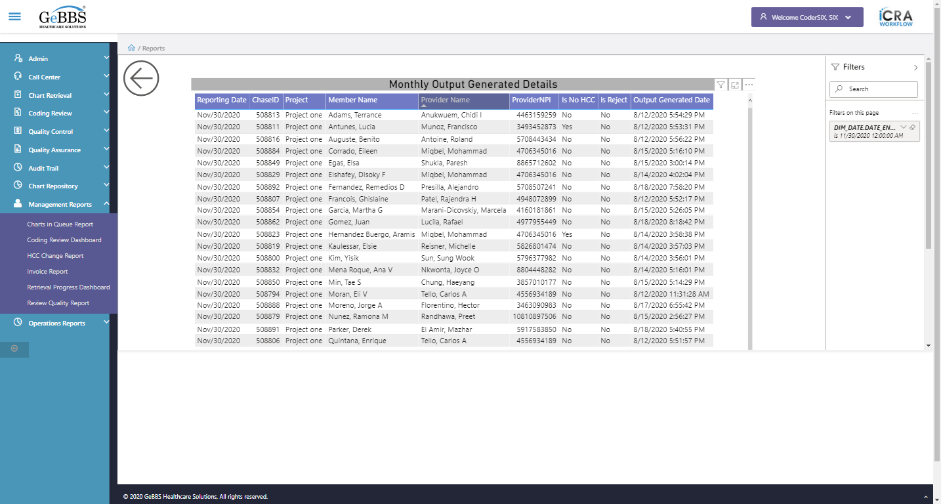  
Coloumn_6 is displayed i.e ProviderNPI  
  
SortIcon_6 is displayed  
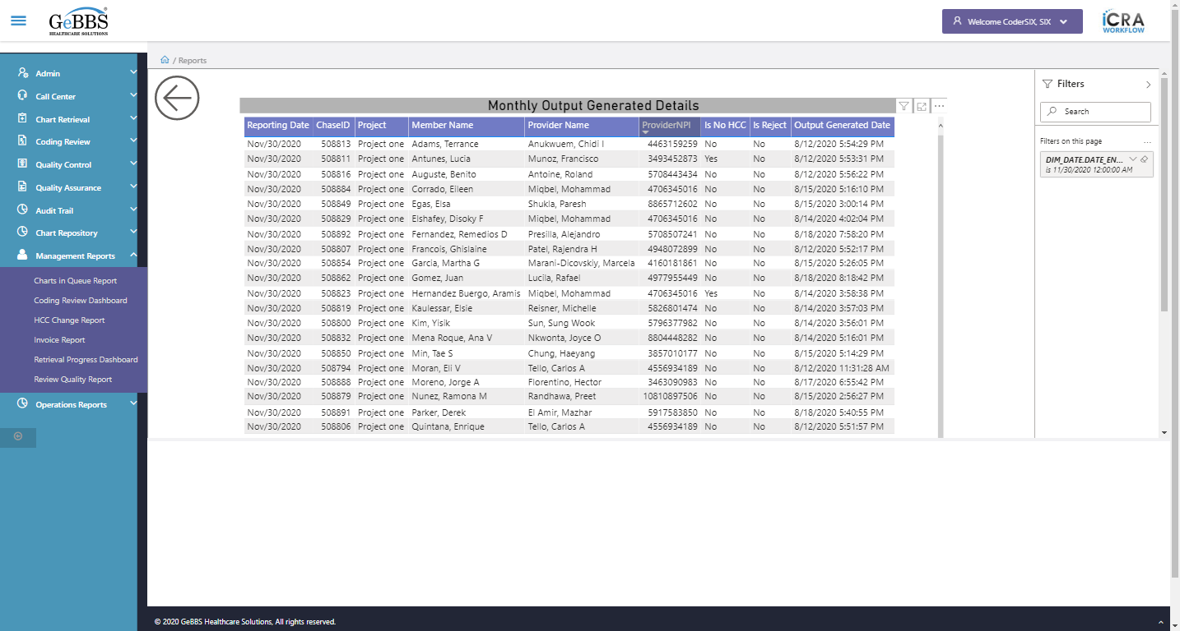  
Coloumn_7 is displayed i.e Is No HCC  
  
SortIcon_7 is displayed  
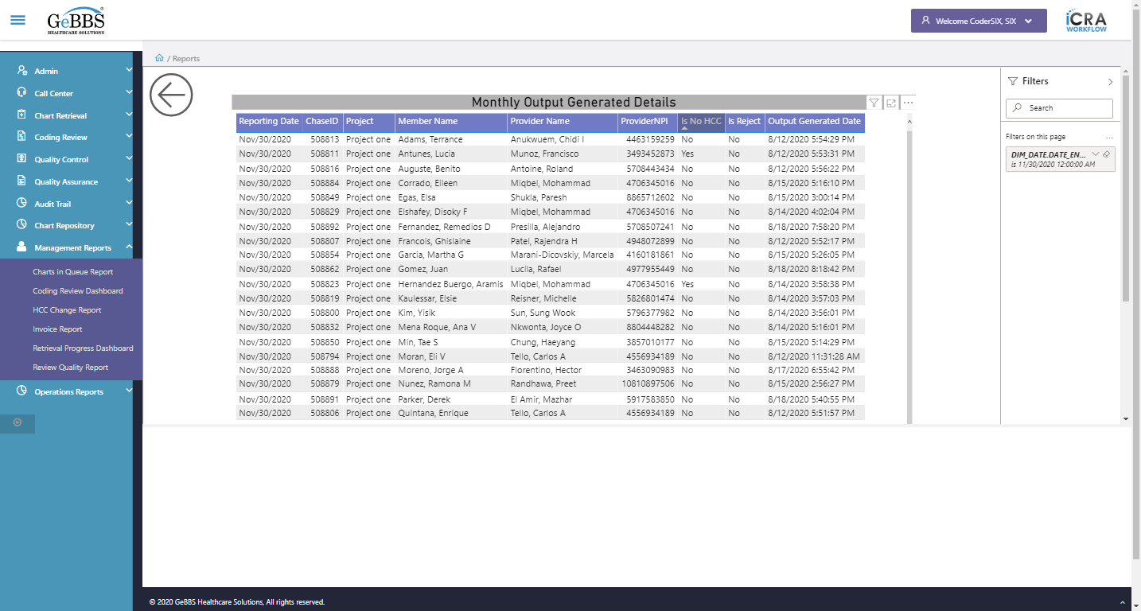  
Coloumn_8 is displayed i.e Is Reject  
  
SortIcon_8 is displayed  
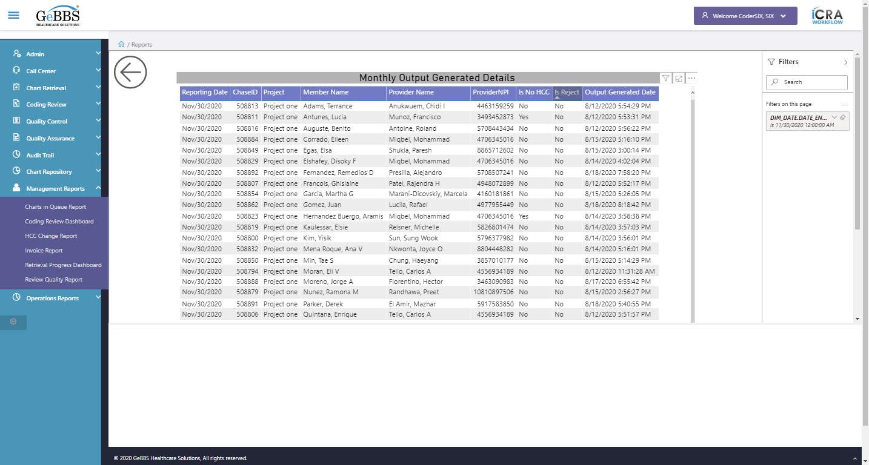  
Coloumn_9 is displayed i.e Output Generated Date  
  
SortIcon_9 is displayed  
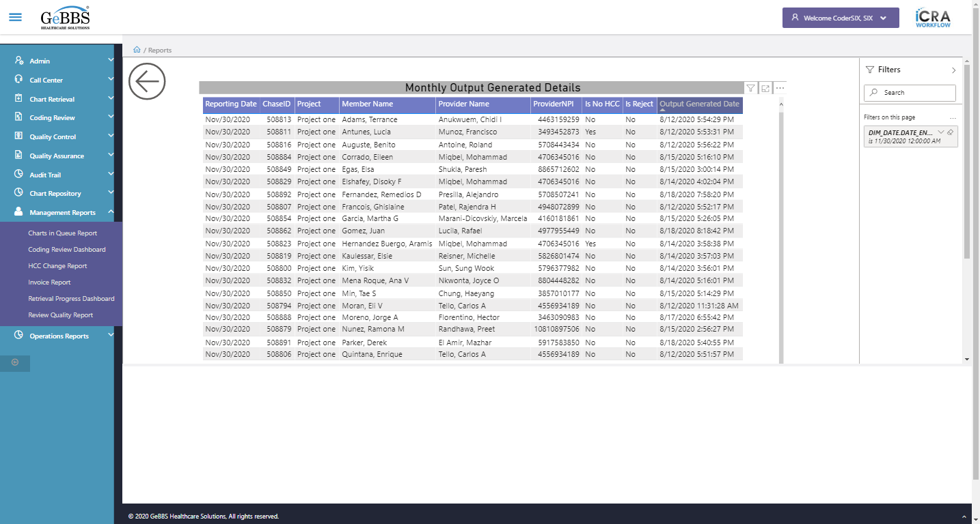  
Heading is clicked  
FilterIcon is displayed  
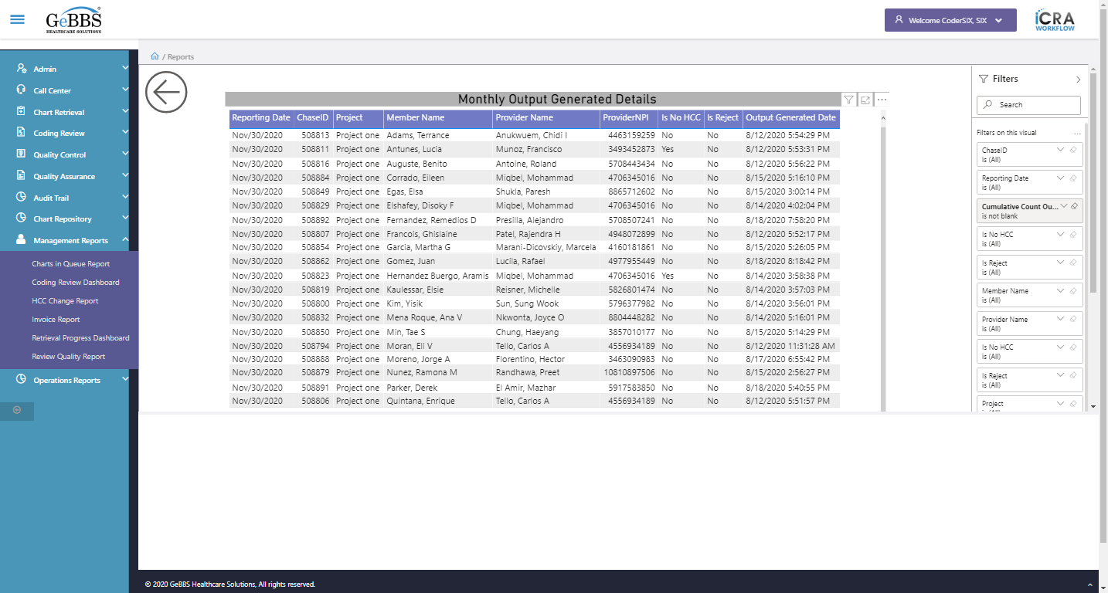  
Attribute for style is : position: absolute; overflow: hidden; width: 1003px; height: 580px;  
FocusMode is displayed  
  
FocusMode is clicked  
Attribute for style is : position: absolute; overflow: hidden; width: 1424px; height: 616px;  
Focus mode is working  
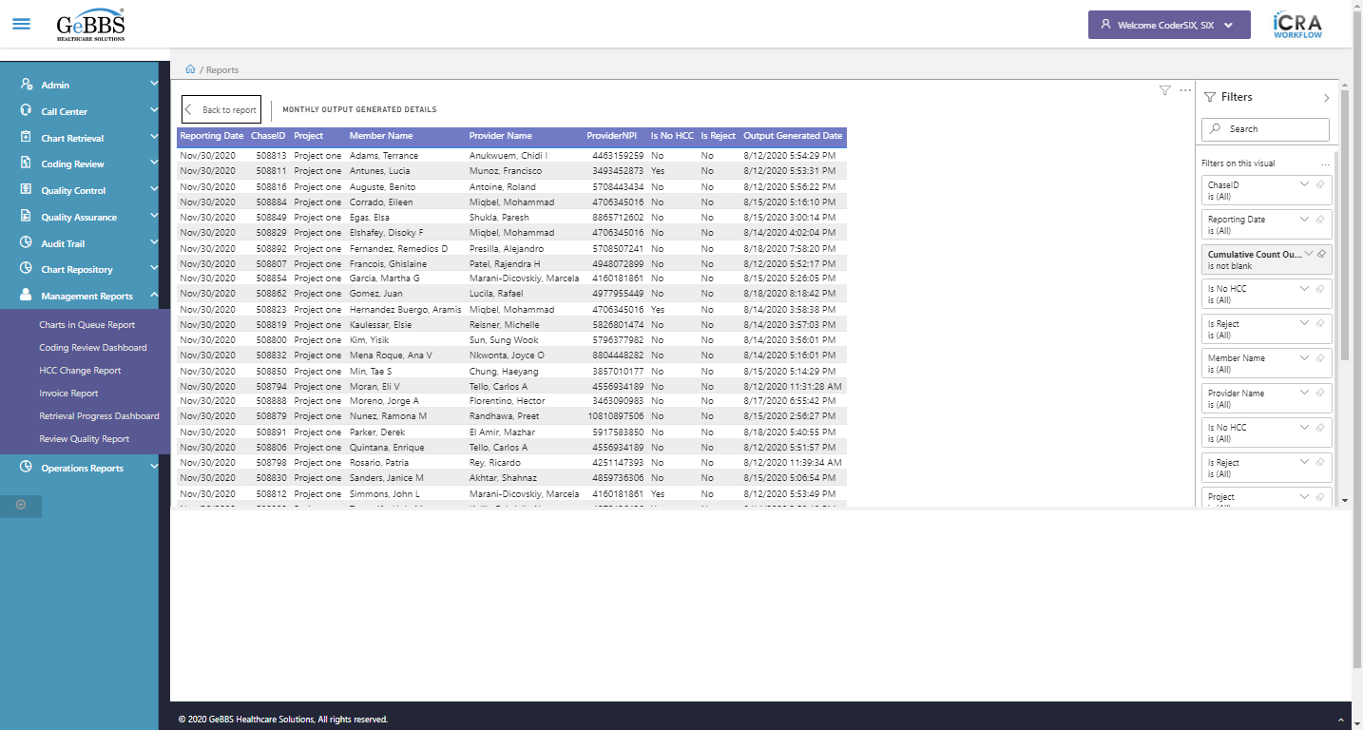  
BackReporticon is clicked  
MoreOptions is displayed  
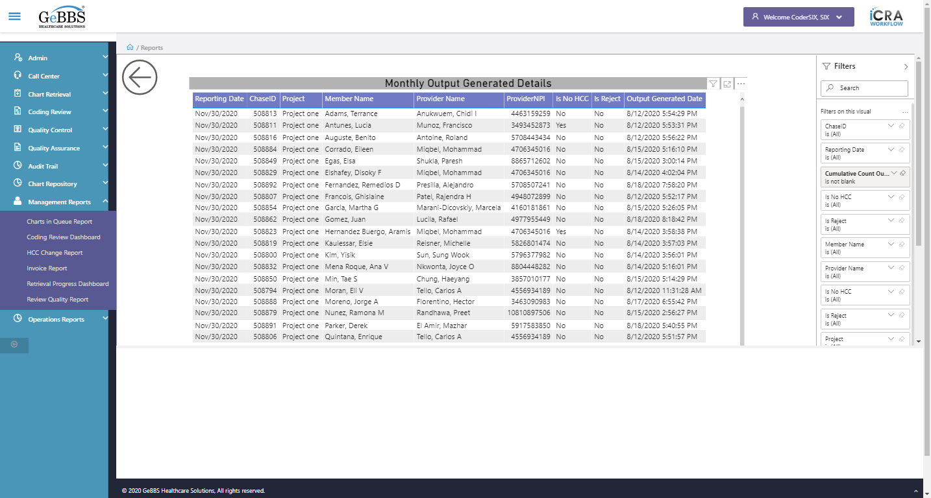  
MoreOptions is clicked  
ExportData_Menu is displayed  
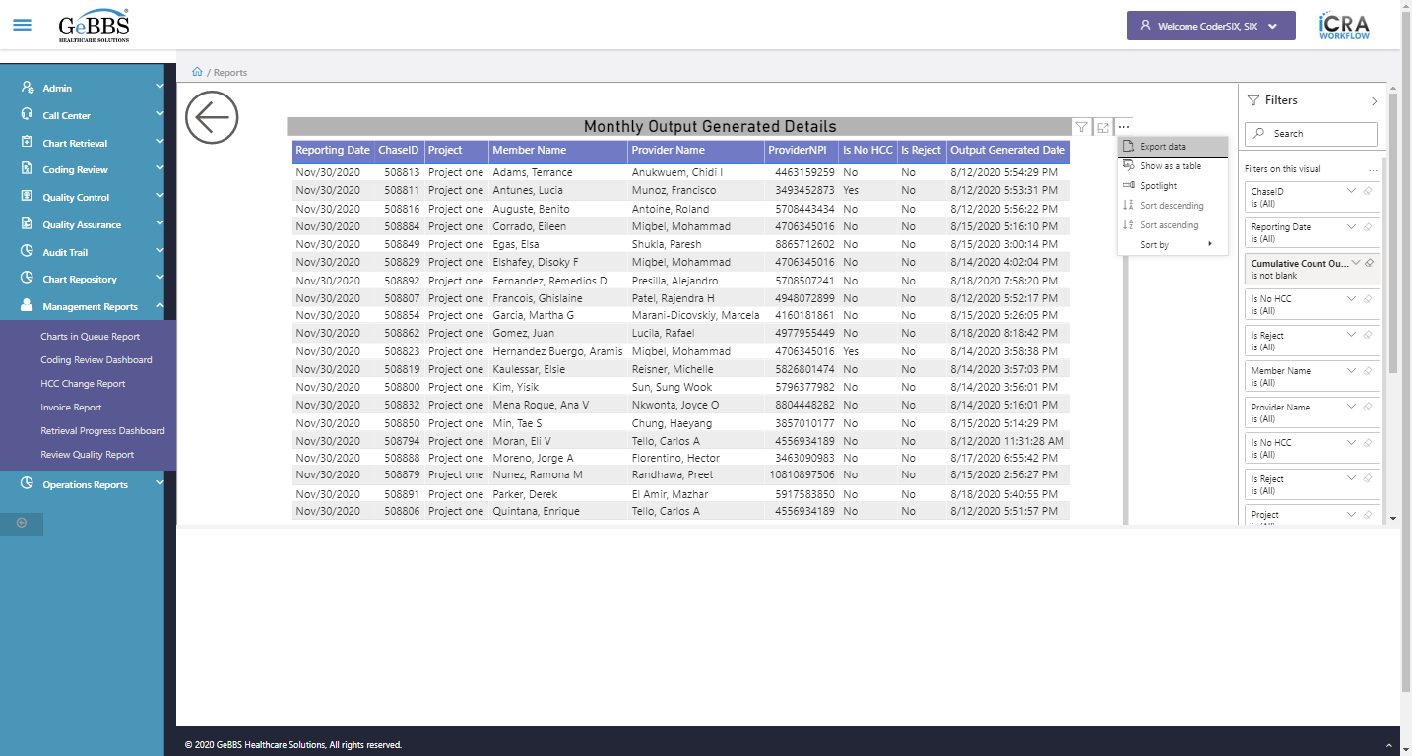  
Showtbl_Menu is displayed  
  
Sortaec_Menu is displayed  
  
Sortdec_Menu is displayed  
  
Sortby_Menu is displayed  
  
Sortaec_Menu is disable  
  
Sortdec_Menu is disable  
  
Sortby_Menu is clicked  
ReportingDate_Menu is displayed  
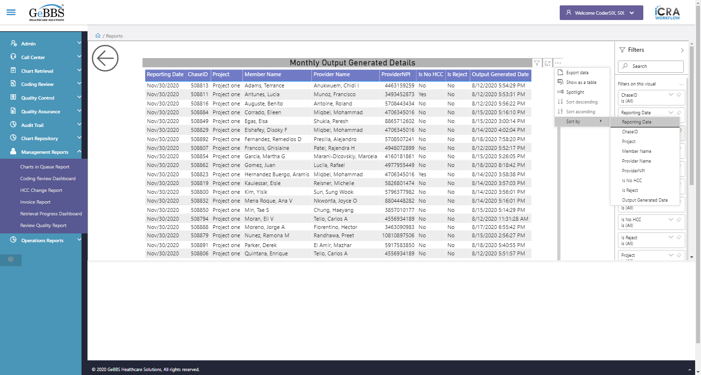  
ChaseID_Menu is displayed  
  
Project_Menu is displayed  
  
MemberName_Menu is displayed  
  
ProviderNPI_Menu is displayed  
  
ProviderName_Menu is not displayed  
  
IsNoHCC_Menu is displayed  
  
IsReject_Menu is displayed  
  
OutputGenerated_Menu is displayed  
  
******** CumulativeMonthlyOut checked ********** **10/11/2020 12:33:34**